96-98 CHARLOTTE STREET: ITS STRUCTURAL HISTORY
A PRELIMINARY REPORT
PART ONE
AN HISTORICAL EVALUATION OF THE HOUSE

BY
ERIC KRAUSE

KRAUSE HOUSE INFO-RESEARCH SOLUTIONS
MARCH 22, 2010
(Revised December 20, 2011)

PROJECT
York Street ↓ ↓ North Charlotte Street
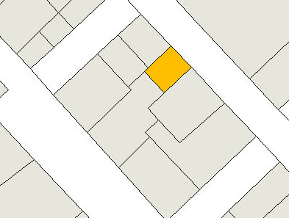
↑ Esplanade ↑ Nepean Street
-----------------------------------
ADI Limited (Sydney) has engaged Krause House Info-Research Solutions to provide an historical evaluation of the house located at 96-98 Charlotte Street, Sydney, Nova Scotia.
SCOPE OF SERVICE
To visit the site in order to identify and photograph elements in the building which are 18th century and early 19th century and prepare a report documenting the findings of the site visits.
PREFACE

On February 9, 2010, a contract with ADI Limited (Sydney) set out the limitations of a preliminary report on a structure at 96-98 North Charlotte Street, Sydney, Cape Breton Island, NS, that had suffered a serious apartment fire on the night of July 5, 2009.

Accordingly, the contractor agreed to:

(A) Identify elements in the building which are 18th (c. 1785-1799) and early 19th (c. 1800-1820) centuries
(B) Distinguish (A) elements from later add-ons (c. 1820s-present)
(C) Take digital images of (A) and (B)
(D) Produce a written report in Microsoft Word format titled “96-98 Charlotte Street: Its Structural History: A Preliminary Report” that interprets and incorporates (A), (B), and selected images from (C)

Subsequently Eric Krause visited the house (30 hours in all) on February 12 (2 hours), February 14 (1 hour), February 15 (1 hour), February 19 (3 hours), February 22 (3 hours), February 23 (3 hours), February 24 (3 hours), February 25 (3 hours), February 26 (2 hours), March 2 (3 hours), March 8 (3 hours) and March 11 (3 hours), where each physical investigation also generated a photographic record (1,400 images to date).

All measurements in this report should be considered approximate only.

This report only discusses the most obvious 18th- and early 19th-century elements. Too many others either exist or are suggested (requiring additional investigation) to mention here in a preliminary report.

Also, the reader will notice that the author has not included some obvious features, such as doors and windows for example, in any detail in this report. Dating these types of features with any confidence, whether they be 18th- or early 19th-century vintage will first require an in-depth examination, that might include, for example, paint analysis, paint stripping, lifting of mouldings with care, etc..

For this study, the following features are under review:

(1) East Building, Basement and Attic
(2) Central West Addition and Basement
(3) Far West Addition (First)
(4) North Addition
(5) First Floor Addition
(6) Far West Addition (Second)
(7) Upgrades Requiring Clarification
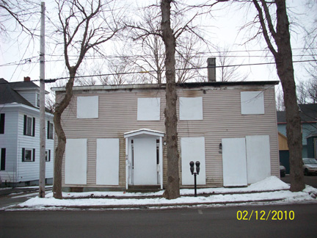
East Elevation (Facing Charlotte Street)
The North Addition exists to the right (north) of the chimney stack. The East Building, including the stack, exists to the left (south). Observed above these structures is the later First Floor Addition.
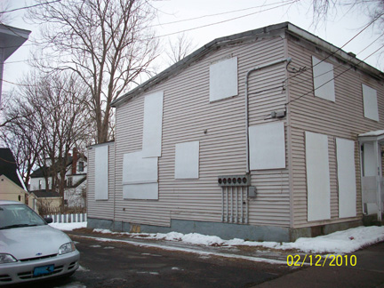
South Elevation
The East Building exists to the right (east) of the change in the foundation elevation. The Central West Addition exists immediately to its left (west), and, beyond, further to the west, the present one-storey Far West Addition (Second).
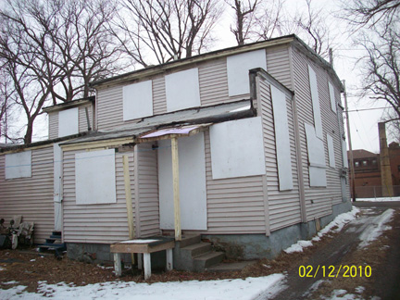
West Elevation
Observed above in the distance is the upper First Floor Addition constructed of two different depths towards the west - one being to the right (south), the other being to the left (north) - raised over the East Building, and Central West and North Additions.
In the foreground is the one-storey Far West Addition (Second).

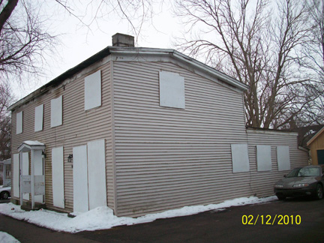
North Elevation

EXECUTIVE SUMMARY
(A) STRUCTURES

(1) East Building: Basement, ground floor, and attic (A representation of late 18th-century materials and techniques).

- This is the period portion (existing) facing Charlotte Street that one enters through the present main entry door.
  - The ground floor consisted of a south room (existing) with a fireplace (not existing), a central corridor (existing), and a north room (existing) with a fireplace (existing).
  - Below was a basement (existing).
  - Above was an attic (partially existing) with a fireplace (existing).
  - The original roof, set upon knee walls (existing), was once gabled (partially existing), north/south (i.e. pitched east/west).
  - Many period materials still exist throughout the structure.

(2) Central West Addition: Basement, ground floor, and attic (A representation of late 18th- and early 19th-century materials and techniques).

- This is the period portion (existing) immediately to the west of the East Building.
  - The ground floor consisted of two rooms - to the south (existing) and to the north (existing) that was sub-divided (ghost).
  - Below was a basement (existing).
  - Above was an attic (partially existing).
  - The roof was saltbox style (partially existing) running westerly off the East Building.
  - Many period materials still exist throughout the structure.

(3) Far West Addition (First): Ground floor and crawl space (A representation of either late 18th-, or early 19th-century materials and techniques).

- This is the period portion (partially existing) beneath the Far West Addition (Second) immediately to the west of the Central West Addition.
  - The ground floor consisted of an unknown number of rooms (partially existing).
  - Below was a crawl space (existing).
  - Some period materials still exist.

(4) North Addition: Ground floor and crawl space (A representation of early 19th-century materials and techniques).

- This is the period portion (existing) facing Charlotte Street that one enters through the present door immediately to the north of the East Building.
  - The ground floor consisted of one room (existing) opposite the East Building and partially opposite the Central West Addition.
  - Below was a crawl space (partially existing).
  - Many period materials still exist throughout the structure.

(5) First Floor Addition: First floor (A representation of late 19th-/ early 20th-century materials and techniques).

- This is the raised portion (existing with fire-damaged rooms) consisting of two portions each with a different depth to the west constructed above the East Building, and Central West and North Additions.
  - Many period materials still exist throughout the structure.

(6) Far West Addition (Second): Ground floor and crawl space (A representation of late 20th-century materials and techniques).

- This is the portion (existing) farthest to the west raised above the Far West Addition (First).
  - Many period materials still exist throughout the structure.

(B) SUGGESTIONS

(1) Carefully remove the existing siding(s) (where not original excepting for the Far West Addition (Second)) down to its remaining sheathing(s) as it is presently hiding significant construction clues, and record - in writing and with photography (Whether a restoration or a demolition).

(2) Later, and carefully, remove the First Floor Addition as it contains many re-used timbers and features from an earlier period that will reveal construction clues, and record - in writing and with photography (Whether a restoration or a demolition).

(3) Then carefully remove modern materials to original materials as they are presently hiding significant construction clues, and record - in writing and with photography (Whether a restoration or a demolition).

(4) Then, finally, re-establish the original saltbox footprint over the East Building and Central West Addition, as well as the North Addition, and record the process - in writing and with photography (If a restoration).

DISCUSSION

I found many 18th- and early 19th- century features to be evocative of those of both the Cossit (built 1785) and Jost (built c. 1785-1787) houses in Sydney, NS, where I spent many hours, in the 1970s and 1990s respectively, as the volunteer consultant who undertook historical investigations prior to their heritage designations. I also found that where similar features still exist in this house they are generally materially and structurally in a better condition than those of the Jost House prior to its restoration.

The removal of the existing modern siding and the covering(s) beneath - given that this last said material is also relatively modern and should be replaced by one more types appropriate to the interpretative period(s) still to be determined - down to the original board sheathing of the complex will no doubt prove most enlightening. Only then can one determine with precision original door and window locations, roof slope(s), etc., and possibly the type(s) of original siding, and even the broad construction dates of these said features.

(1) EAST BUILDING: 18TH-CENTURY STYLE HEAVY TIMBER FRAME CONSTRUCTION

The building on this site displays many materials and techniques of the late 18th century. In fact, so many, that this section will only highlight a few of the most notable ones.

To the north, from its south-east corner, along Charlotte Street the building measured 31 1/2 feet (three ground floor bays across defined by two framed interior walls) in length, but to the west only 16 1/2 feet in depth (one ground floor bay). Beneath, the basement (existing) and its two "rubblestone" foundations (existing) are original (see below for an additional foundation and basement discussion), as are the structure's 10 widely-spaced ground-floor framed joists (existing), and 4 perimeter ground-sills (existing).

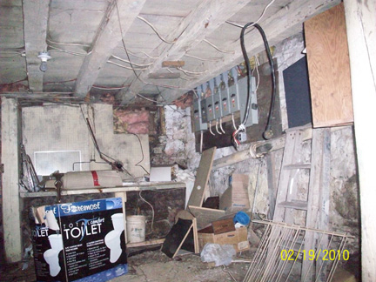
East Building Basement
South-East Corner

Above, the ground floor consisted of a central bay (existing corridor defined by two framed walls) opening upon Charlotte Street, servicing a single bay (existing room) to the south and a single bay (mostly existing room) to the north. Each room had a fireplace, one (existing) in the north one against its north wall, and another (not existing) in the south one standing against its west wall. Flooring (existing) consisted of two layers of relatively finished, very wide, tightly-fitted boards, with the upper layer being tongued and grooved.

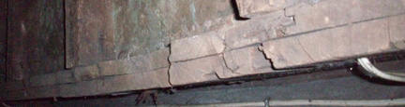
East Building Ground Floor
Two layers of flooring boards with the upper layer having tongues and grooves

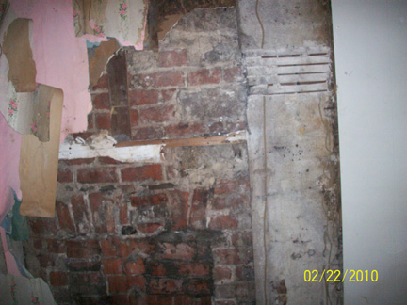
East Building, North Ground Floor Room
Blocked Fireplace
To the right (east) a portion of the new North Addition wall (see later) showing machine cut laths

Walls and ceilings had an 18th-century mortar plaster finish (some existing, some ghosts) set upon hand-split laths (some existing, some ghosts).

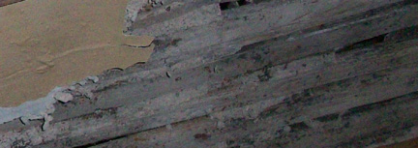

East Building, North Ground Floor Room Ceiling
18th-century hand-split lath work and plaster work

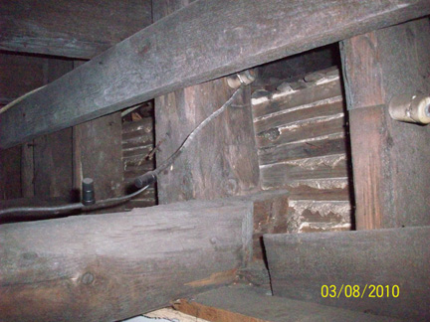

The West Wall Of The North Ground Floor Room Of The East Building Observed From The First Floor Addition Side (see later)
The west wall and ceiling with their 18th-century finishes of mortar plaster upon hand-split laths

Knee wall construction (existing) produced a functioning attic, featuring hand-split lath and mortar plaster work (partially existing) and single-layered tongue and grooved board floors (existing), set upon flooring joists (existing) under a pitched roof (some rafters exist). At least one fireplace (existing) - the one against its north wall - served this upper place.

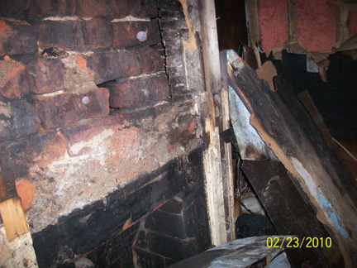
East Building Attic
Fireplace and 18th-century hand-split lathwork (To the east, upper right)

- Foundation and Basement Discussion

The East Building, in the beginning, either had a functioning basement (existing), or only a crawl space beneath, with the structure resting upon a low foundation. If the last-named were the case then the digging of the basement and the creation of the existing foundations occurred soon after, no doubt during the Central West Addition (see next) construction phase.

(2) CENTRAL WEST ADDDITION: 18TH-CENTURY STYLE HEAVY FRAME CONSTRUCTION

Added to the west of the East Building, utilizing its west wall as a common wall (existing), were two additional ground floor bays (existing) or rooms (south and north) where, apparently later, an interior framed partition wall (ghost) sub-divided the northern bay into east and west rooms. Beneath the addition was a basement (existing) and above an attic (partially existing) closed off by a saltbox roof (remnants existing) that had upon its west slope, north portion, at least one dormer (remnants exists).

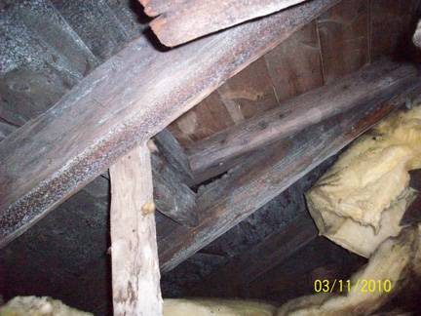
Central West Addition Attic
The Portion Existing Above The North Ground Floor Room
Rafters, roof sheathing boards and apparent "dormer" opening (later blocked) of the saltbox roof

In the basement, new south and north "rubblestone" foundation walls (mostly existing) extended westerly off those (existing) of the East Building. Under one scenario (see above, East Building, foundation and basement discussion) this work included the removal of the west foundation of the East Building and its masonry reconstruction (existing) about 12 feet further to the west. Set upon them, but placed lower in elevation than those of the East Building were four new ground sills (existing), with relatively widely-spaced framed flooring joists (existing, north portion only).

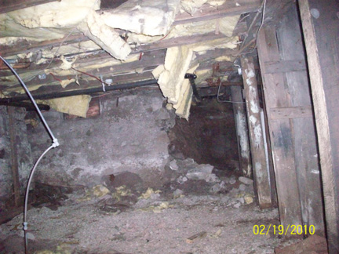
Central West Addition, North Basement Portion
The north foundation wall originally closed off the entire opening to the right (east). The joists and ground sills are set lower than the ground sills of the East Building out of sight to the right (east).

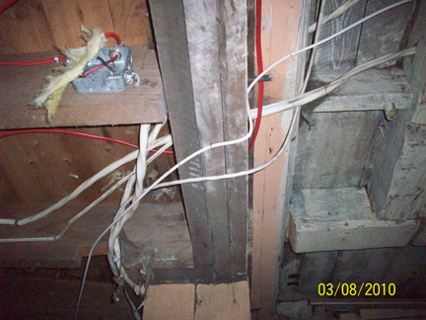
Central West Addition, South Basement Portion To The Left (West)
Here the flooring level was set lower than the flooring level of the East Building to the right (east). As well, later joists are nailed to a later ground sill (consisting of three beams) upon which sits later flooring boards.
Note: Out of sight to the left (west), the later joists are nailed to a later ground sill nailed to the period west ground sill of the Central West Addition.

In its northern portion, in an unusual manner, the Central West Addition (or visa-versa) shared its west masonry foundation with the Far West Addition (First) (or visa-versa: see next). Incorporated but below its own ground sill (existing) was the ground sill (existing) of the Far West Addition (First).

In its southern portion introduced was brickwork to provide the ground sill support.

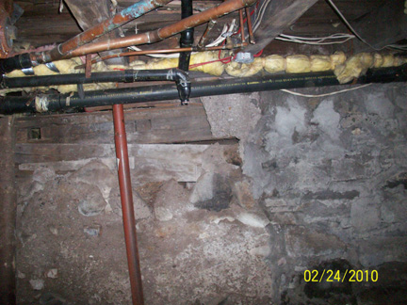
Central West Addition Basement
Central West Addition ground sill running above that (with open mortise holes) of the Far West Addition (First)

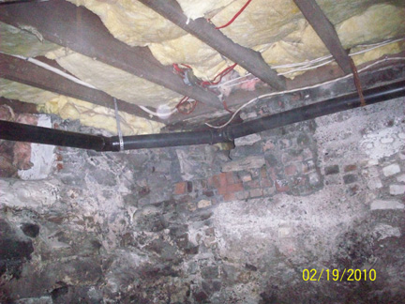
Central West Addition Basement
Brickwork in the west foundation - The brickwork continues further to the right (north).

The ground floor flooring consisted of two-layers of very wide boards (partially existing) - the bottom ones slightly rough, and not laid tight to each other, and so differ from, yet are similar to, those of the East House. Finished were its interior walls, in some places with wide tongued and grooved boards (existing) placed horizontally from floor to ceiling, while, at other locations, with 18th-century style mortar plaster (partially existing) set upon hand-split laths (partially existing). Also, at least some ceilings had a lath (ghosts) and [mortar] plaster finish.

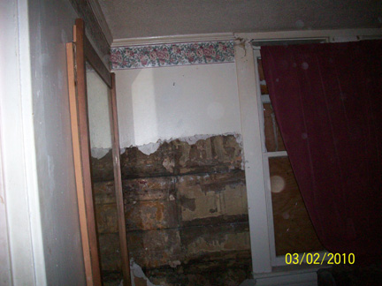

Central West Addition South Room
Boarded perimeter wall consisting of floor to ceiling, horizontally placed, tongued and grooved, wide boards

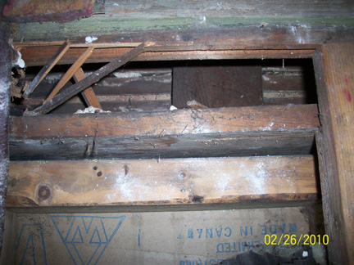
View Through The South Wall Of The North Addition And Into The North Room Of The Central West Addition
Hand-split laths - nailed to a vertical board - with a mortar plaster finish
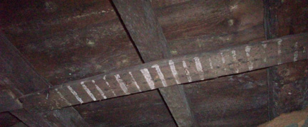

Central West Addition South Room Ceiling
Lathing board for accepting laths and plaster (ghosts)

Set upon the exterior perimeter sheathing boards (apparently existing) of the East Building were the east ends of the attic flooring joists (existing), of which some were perhaps re-used. Upon them placed was a single layer of tongued and grooved flooring boards (mostly existing).

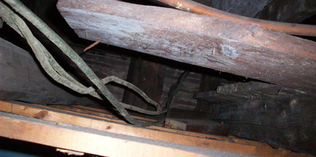
Central West Addition North Room Ceiling
Joists and flooring boards of the saltbox attic

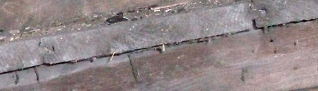
Central West Addition Attic Above The South Room
Single layer of tongued and grooved flooring boards resting upon a joist

In the attic, as at ground level, the attic floor of the Central West Addition stood somewhat lower in elevation than that of the same in the East Building.

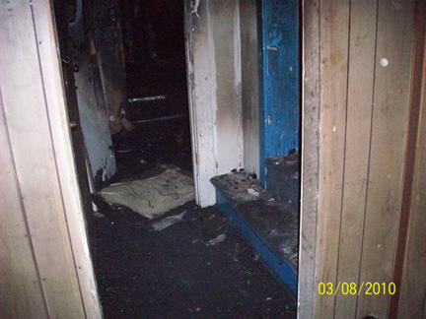

Attic Above The Southern Portion Of The West Central Addition
In the foreground: To the right (east) stepping up to reach the attic floor above the East Building; To the left (west), the floor level of the attic above the south portion of the Central West Addition.
In the distance (north): Stepping up to a later attic floor (see later - First Floor Addition) above the north portion of the Central West Addition and above the North Addition.

(3) FAR WEST ADDITION (FIRST): 18TH-OR EARLY-19TH-CENTURY STYLE HEAVY FRAME CONSTRUCTION

This addition existed immediately to the west of the Central West Addition.

What is known about this structure is little. It rested upon raised foundations (existing), over a crawl space (existing), that the Far West Addition (Second) later incorporated - except for perhaps for the south one. The structure had a ground sill (existing) that utilized open mortises (existing) for its flooring joists (partially existing) that in elevation, sat below that of the ground sill (existing) and flooring joists (existing) of the Central West Addition (see earlier discussion). It also had exterior framed walls (partially existing) that utilized 18th-century-early 19th-century style joinery (existing).

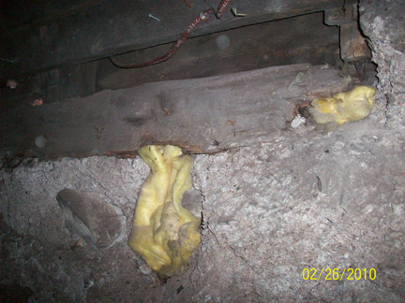

Far West Addition (First) Basement North Wall
Two vertical exterior wall studs tenoned into mortises in the ground sill

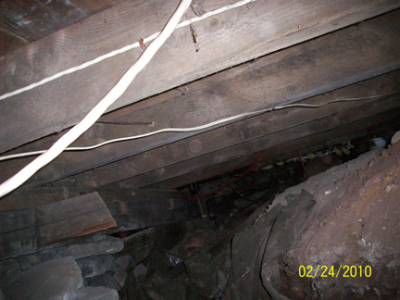

Far West Addition (First)
Above: The Far West Addition (Second) nailed flooring joists
Below: Ground sill with a flooring joist remnant tenoned into an open mortise, and several open mortises beyond

(4) NORTH ADDITION: EARLY 19TH-CENTURY STYLE HEAVY FRAME CONSTRUCTION

This addition existed immediately to the north of the East Building and partially along the north wall of the Central West Addition where the wall of the last named was utilized as a common wall (existing).

This addition arose sometime after the construction of the Central West Addition, built upon low rubblestone foundations (existing) with beneath a crawl space (partially existing). Framed to the north into two ground sills (existing) were the ground floor joists (existing), one out of character being a re-used beam. Framed to the south they were set into the ground sill (existing) of the East Building at one elevation, as well into the ground sill (existing) of the Central West Addition at a lower elevation. Here, however, the last named ground sill ran for only a partial distance towards the west where a new North Addition foundation wall (existing) intersected the foundation (existing partially) of the Central West addition.

The bottom layer of ground floor flooring boards were relatively narrow, thick, and rough, placed, as explained above, in elevation at two different flooring levels.

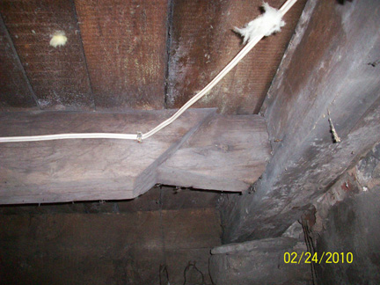

North Addition Basement
South end of a joist: Re-used single shouldered timber (former knee brace?)

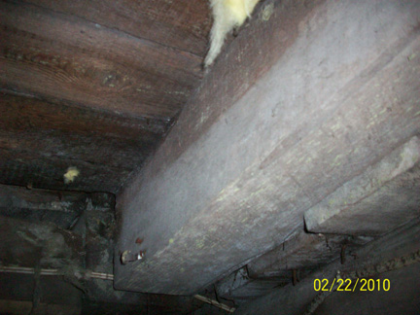

North Addition
Flooring boards - East (left) floor set higher than the west (right) short portion that ended at the room's west wall

Of interest, and perhaps of significance, the ground floor room's west wall (existing) not only was approximately in line with the framed partition wall (ghost) that sub-divided the ground floor north bay of the Central West Addition into east and west rooms, but also was approximately in line with the perimeter west wall (existing) of the First Floor Addition that stood above it.

During the construction of the North Addition, either severed at ceiling level, leaving remnants (existing), or entirely removed was a run of ground floor vertical framing posts between the corner posts (existing) of the north wall of the East Building. Replacing this wall was a new one (existing) constructed further south in line with the face of the fireplace (existing) of the East Building. Nailed then to these post remnants were the ceiling joists (existing) for the North Addition.

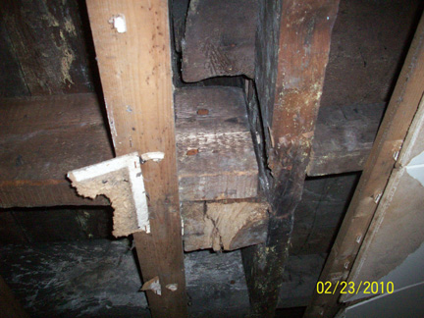
North Addition
Joist nailed to a severed wall post

Applied to its interior walls were wide tongued and grooved boards placed horizontally from floor to ceiling.

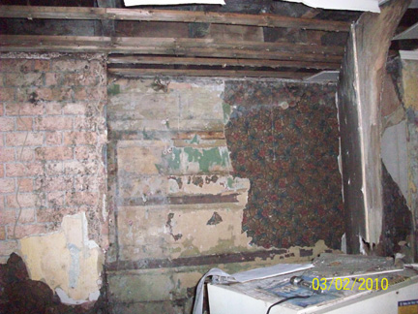
North Addition South Wall
Boarded interior wall consisting of floor to ceiling, horizontally placed, tongued and grooved, wide boards, with shelving ghosts

Perhaps it was during this phase that saw the installation of the existing four windows facing Charlotte Street. While the windows were evocative of late 18th-century windows, their mullions appear to be too light for the period attributed to the East Building where these windows also exist.

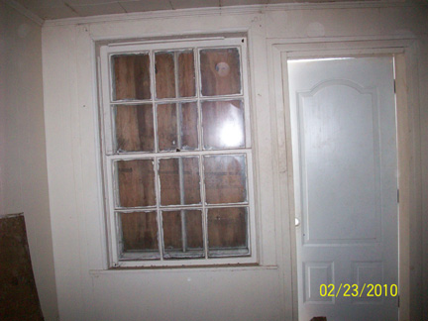
North Addition
Six-Over-Six Window

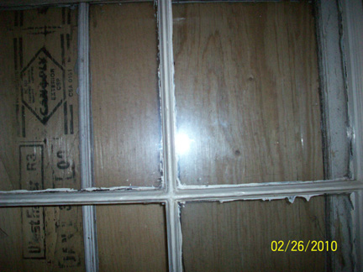

East Building - North Room
Mullions detail

(5) FIRST FLOOR ADDITION: LATE 19TH-/EARLY 20TH-CENTURY LIGHT FRAME CONSTRUCTION

One way to look at this raised First Floor Addition is that it consisted of two sections (existing), each of a different depth to the west, each with a different flooring goal in mind, raised over the East Building, and Central West and North Additions.

The northern portion, which did not extend as far west as the southern one, set its flooring (existing) at the same level throughout by elevating that section west of the west wall of the East Building. At this time, the addition (existing) to the west of the North Addition may not have yet existed.

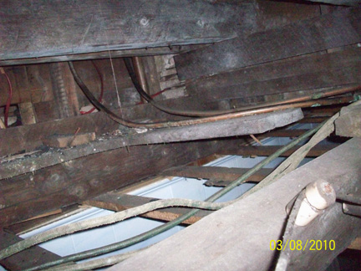

First Floor Addition Above The North Room Of The Central West Addition
Set were new flooring joists placed above the initial ground floor ceiling joists.
Please note the tongued and grooved floor boards of the saltbox attic.

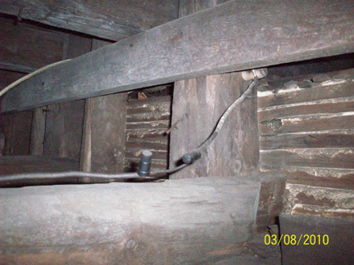
First Floor Addition Above The North Room Of The Central West Addition
Above: A cross beam nailed to the west perimeter vertical posts of the East Building as support for the new joists.
Below: A possible re-used joist for the saltbox floor set upon the assumed sheathing boards of the East Building.

Occasionally re-used in the raising of the floor were some beams (existing), recovered from the saltbox roof.

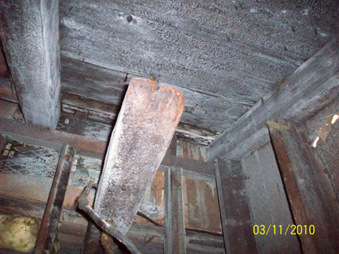
First Floor Addition Above The North Room Of The Central West Addition
In the foreground observed is the end of a beveled timber re-used as a new flooring joist passing through a portion of the raised west wall in the distance. Above, passing through the same raised portion are the remains of the rafters and sheathing boards (wide) of the saltbox roof of the West Addition (see earlier).
The southern portion, which extended to the west wall of the Central West Addition, accepted that its flooring above the East Building stood somewhat higher than above the Central West Addition. In other words, it kept the flooring system of the former saltbox attic.

(6) FAR WEST ADDITION (SECOND) - LATE 20TH-CENTURY LIGHT FRAME CONSTRUCTION

The flooring (existing) was constructed above, even as it mostly utilized below the west foundation system (existing) of the earlier Far West Addition (First). For example, in its northern portion (existing) the new addition incorporated both the west ground sill (existing) and the north ground sill (existing) and vertical posts (existing partially) of the earlier one into its support system.

Perhaps added at this time was that portion (existing) in the corner to the west of the North Addition and to the north of the Central West and Far West (First) Additions.

While for sure this is a modern construction, required is further investigation to determine whether other earlier materials were likewise incorporated into its design.

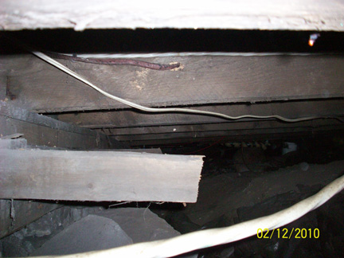

Far West Addition (Second)
Above: Flooring for the Far West Addition (Second)
Below: The remnants of the Far West Addition (First)

(7) UPGRADES REQUIRING CLARIFICATION

Set within the East Building stairwell opening (existing), crudely cut through ground floor flooring boards (existing) rather than placed within a standard 18th-century style framed opening, is the basement staircase (existing). Paired with it is a staircase (existing) to the First Floor that may once have stood elsewhere, perhaps immediately to the north of its present location.

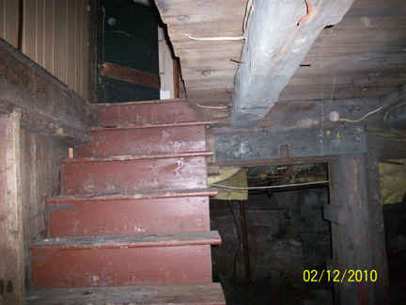

East Building Basement
Stairwell opening and staircase

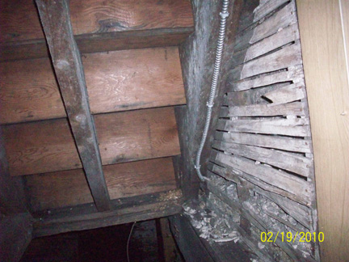
East Building Basement
Staircase To The First Floor
Note the 18th-Century, hand-split lath and mortar plastered wall to the right (south).

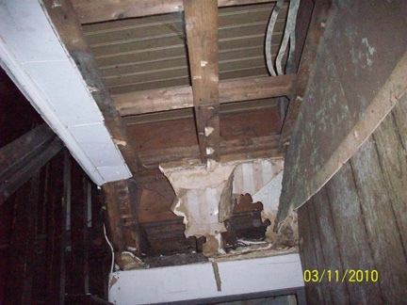

East Building Corridor
First Floor staircase to the left (south)
Possible blocked [stairwell] opening in the ceiling to the right (north)

