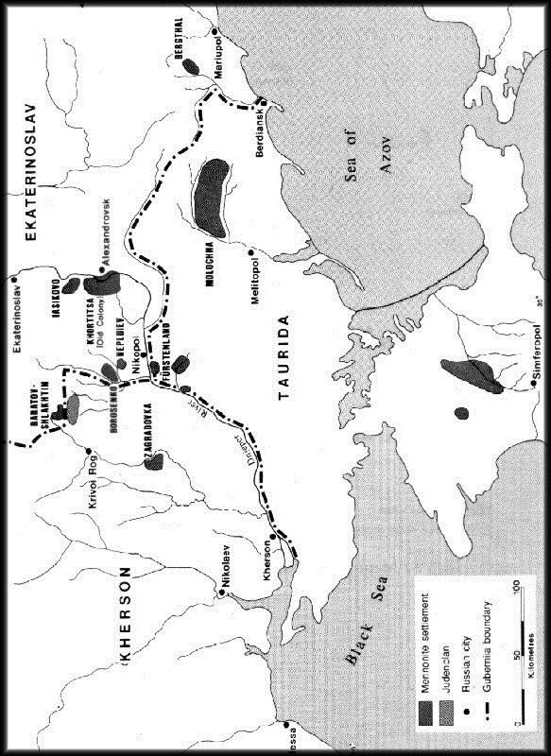

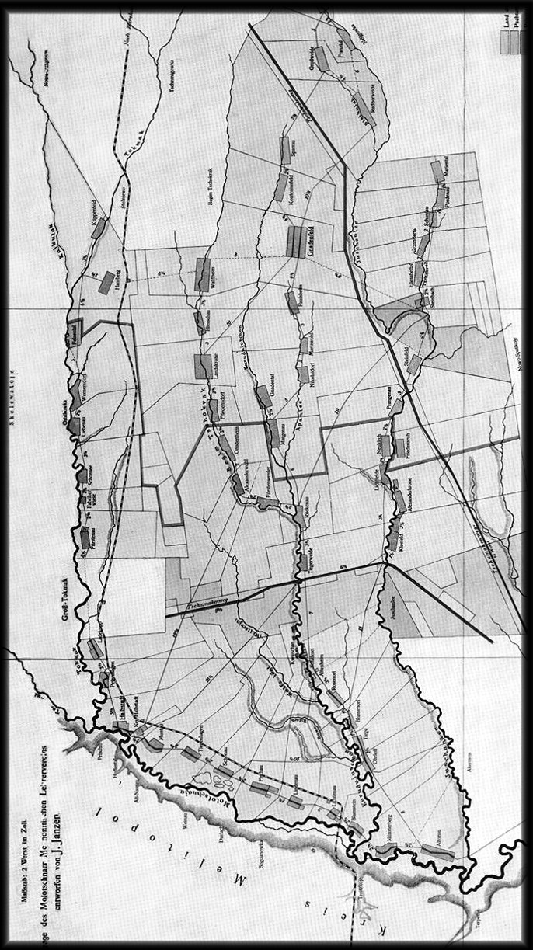

Liesa’s Journey

By Elisabeth Reger (nee Kornelsen)
Written in 1983 in Paderborn, Germany

I was born in Tiegenhagen, Molotschna CoIony in Russia. My parents were Heinrich Kornelsen and Anna (nee Kroeker). It is with a heavy heart that I put my dark past onto paper. But I will try to give a summary of our family life over the years. It would be easier to tell about it. I will start in my childhood, as far as I remember.
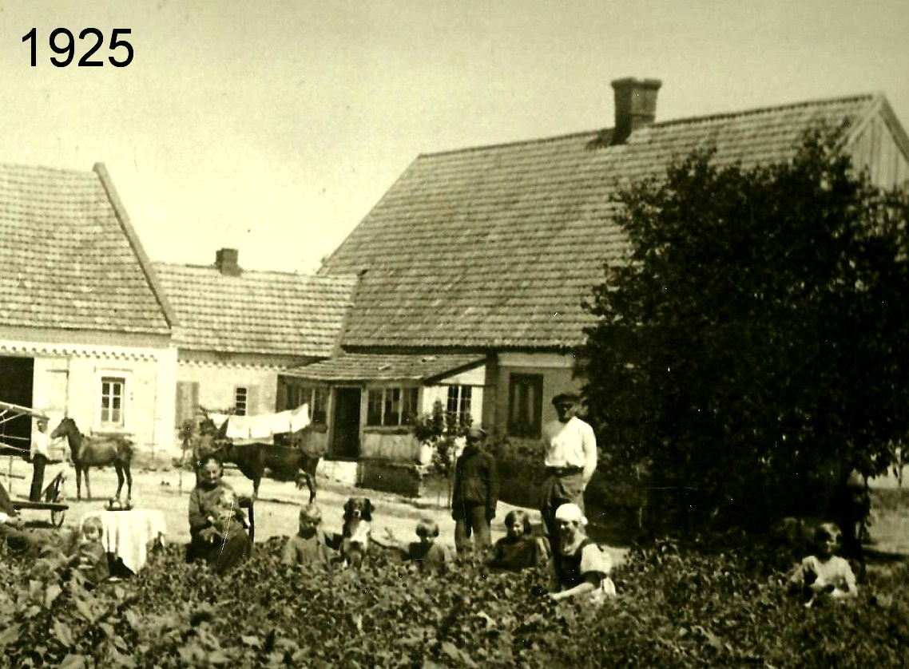

I am in the centre of the picture to the right of the dog

I was five years old in 1921, when the last German soldiers withdrew from Russia. My sister Mariechen who was married to a Willie Krause, went with them. At the time, they already had a little son, just a baby, in the travel cradle. I remembered that time, as from then on we suffered of terrible hunger.
Besides me, Liesa, and my parents, there were also my siblings Lena, Jasch, Heins, Nut, Sascha, Sara, Katja. Except for Mariechen, we were still all together.

Then the American Aid arrived. They brought in products, and a kitchen was opened, where we could pick up food. We were saved, but many fell victim to starvation. I became very quiet and did no longer ask for food, as my stomach had shrivelled. When some sort of peace had returned, they granted us land. How the parents seeded and planted, is beyond me. Where did they get the seed? There was bread on our table; the Lord had given his blessing! We also had a big harvest.

And so it went until 1924 or 1925. Then it became difficult again. The Germans in our villages started to emigrate to Canada. The villages emptied. Also, of our relatives nobody was left, only our father, mother and five children. Papa always had an eye infection, and the commission did not pass him to emigrate. When the grandparents were about to leave, they transferred their big house to our father, and ours was sold instead. They used the money for their departure, and we stayed behind. But there were also debts our father was left with. He was asked to pay out the siblings, once we should be allowed to travel. But events took a different turn - Man thinks, God guides!

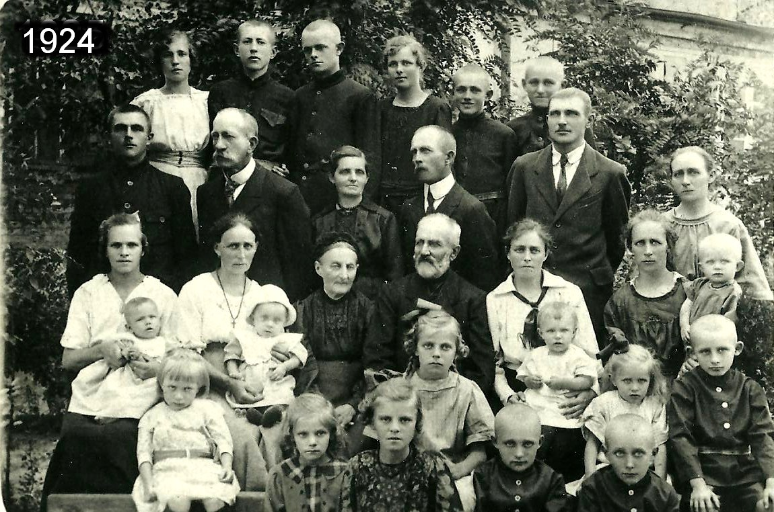

Back row: Mary Schellenberg, George Schellenberg, Henry Kornelsen, Anna Kornelsen, Sascha Kornelsen, Jacob Penner
Next: Jacob Kornelsen, Gerhard Schellenberg, Anna (nee Kroeker)& Henry Kornelsen, Henry Willms,Helen (nee Kornelsen) Penner
Next: Clara (nee Moss) Kornelsen with Maria, Sara (nee Kornelsen) Schellenberg with Jacob, Helena (nee Martens) & Jacob Kornelsen, Maria (nee Kornelsen) Willms with Mary, Katherine (nee Kornelsen) Thiessen with Katherine
Front row: Helen Schellenberg, Liesa Kornelsen, Sara Kornelsen, Katherina Kornelsen, Henry Penner, George Penner. Behind George: Hedwig (Hedie) Thiessen, John Penner

The furniture in the house were old but good, except for some which the dreadful murderer and bandit Makhno* had sold and robbed. There existed various gangs during the Revolution.

*Wikipedia: Nestor I. Makhno, born in 1888 in Ukraine, in office 1919-21.Anarcho-communist guerrilla leader, turned commander of the Anarchist Black Army. They raided and ravaged Mennonite villages because of their wealth and their alleged support of the Tsar. Mennonites described him as "an inhuman monster whose path is drenched in blood".

When we moved into the big house, we found an old horse in the stable; we brought a lame horse and two cows with us, with which we worked the land and which should provide us with milk. Time heals wounds, and for years our lives were in order. Papa was close to animals and was especially interested in good cows, it was worth his efforts. Until 1925 Papa and the family worked the land together. We lived with the grandparents until they emigrated, and aunt Lena Penner with her four boys of the same age as ours. Their father had been murdered by Makhno. I remember the father, how around 1918 he swung me on his feet. In 1925 we saw them off at the Lichtenau Station. There were whole trains with our people; what crying and screaming it was, as they left. The ones in the trains and those on the platforms sang: God be with you, until we see each other again! It was very difficult to stay behind.

When we came home in the evening, all was quiet around us, bright moonlight and only the howling dogs of the owners who had left. It was a scary feeling. Afterwards other people came to the village; time does not stand still. In those days, the church was open for services, and Christian festivities were allowed. There was peace again. Sunday school was nice. I also went, always on time. And then came the beautiful Christmas holidays. How happy we were about every little thing. So it went until 1930.

Then terrible times started again! They took our livestock - whoever had any hay, they took. They organized a general co-operative which they called Colchos (co-operative), but without God. The Lord was ignored, the churches locked up or converted into clubs or storehouses for grain or other things. God’s blessing and his patience were great. The Lord granted a good harvest, but it was not a blessing for us. The government took it all. The workers had to ration their bread. They only got little for what they had worked so hard for. The top people took all, what they did with it, was found out later. Then all of a sudden we were considered wealthy.

In 1931, brother Sasch was drafted, but he refused to carry a rifle. He went to the unarmed service - an inhuman service - they were housed in wooden barracks infested with cockroaches which tormented them by night. Sister Nut and her husband visited there, brought him plums from the trees behind the house, but a bag full of dried ones, nothing much, because we had nothing ourselves. The nights we spent there, were horrible. In the morning our faces were swollen with cockroach bites. Our poor brother had to suffer there for two years. Thank God, he returned home alright, he was a child of God. Sasch was converted and also baptised.

The cup was not full yet, the rage of the terrible enemy was only starting. Our family was thrown out of the house, and our last belongings were taken away, furniture, beds, clothing, dishes. Only the most necessary was left to us .And then there was the question, where could we turn to; those who took us in, were in danger themselves. But good people gave us a small room in a clay house covered with reeds. We had to work as prisoners, and for half of what others were paid. Again we suffered hunger, but God does not abandon his own. I understand that well now. It was our dear aunt Lena Penner in Canada, aunt Sara, our dear brothers Jacob, Heins, all of them were involved in the good work and sent us the odd dollar in their letters. It saved our lives. Today I know that it came from God. His ways are sometimes miraculous and good. Yes, at the time we were considered “once wealthy”, and that meant, we were enemies in our own country. That's how we were treated. But what we had owned before 1930, had been earned honestly by our dear father, mother and children, and we lived with God's help and blessing, not in high style, like the people who had taken it from us.

This went on until 1934. Then our situation became better. They admitted that it had been a mistake to drive the people away from their villages. And so we received equal pay for our work.

But first I want to talk about a serious event in 1939, when we were permitted to move to Nut. We lived with her. We all were very hungry. I found a position where I could tidy up, first twice a week and then nearly every day. I was fed there and got a glass with gruel for my son, who was already waiting for it when I got home. One evening, on the 30th of May, we were sitting together and talked about things we were worrying about. I pointed out: "Tomorrow is my birthday, who knows what will happen."

What terror! We found out instantly, it happened after midnight - usually disaster strikes at night -
the so called Black Crow picked up Papa and brother Sascha to prison. Why and what for? We will never know. My birthday was filled with tears and misery. In the morning I went to see them and found that they had been transported to the prison in Halbstadt. Papa was released after a week, but Sascha had to stay. The question was, if he and his family would be sent to the North. But again the Lord protected us in our misery. After a month, they let my brother go. What joy!

Now I continue with 1934.
I had a cleaning job, but I was very weak and once I saw black. The Russian who supervised the corn and food depot, saw that I was close to collapsing. He gave me a knife and said: "You go and sweep the compartment over there, you will find bread and butter there and you can eat until you are full. I did so and also made nice order in there. I was eighteen years old.

Another time, when I was sixteen, I had an extremely hard time, doing a digging job. They measured length, width and depth. It was an official regulation. One had to pile up the dug up soil in order to build a wall. On top the water would flow and then irrigate the vegetables. The following morning, our sides where tumid and swollen, but there was no pity for us. We all had to work the following day, even with Malaria. Every other day many could only work until noon, then the fever felled me and my siblings, it was terrible! The next day we worked again, so weakened by the fever.
About 1935 I was sent to take a course for a month, to become a daycare worker. From then on life improved. I was allowed to eat the bread crusts which were left by the children. My looks also improved; after times of hunger, humans gain weight quickly, as long as one gets enough to eat, no matter what it is. Living was easier, but there were so many atheists around in the world, the church was locked. They were using it as a club. I was also young, and the seeds our dear parents had sown into our hearts, were dormant for a long time. Only a small ember glimmered, but the Lord said that he will not break the bent blade of grass and not put out the glowing wick, the Lord kept his word.

Then came the year 1936.
This year was also very eventful, as well for our family. LIfe became easier, my work was at the daycare center. The administration was happy with me. My sisters Sara and Katja worked at the silk worm factory doing sewing. Nut was employed at the bakery, we no longer suffered of hunger. There was not much of clothing and shoes, used dresses from Marle - who knows who wore them before - and also from Katun. Shoes were a problem.

Before Christmas 1935, I was sent to a second course, and in fall all five siblings received a bonus for good work in the co-operative. Afterwards something happened, I had not counted on. I had scarlet fever, but was getting better. In the club they had harvest fest dinner and dance music, while I was still tired and weak at home. The bonus was given out there. It was a Saturday. Mama came to me in the evening and brought me brown silk for a dress, my bonus. She told me that the shepherd’s daughter (Russian) had just passed by and said to aunt Kornelsen:"On your roof hoots an owl, somebody will die in your house." Certainly we and our lives are not depending on an owl, but a few days later, our dear Mama laid down, and the doctor said, it was pneumonia. A week later on Sunday, October 10, she went home. It was hard to believe, but today I can say, that she has been saved from a lot of misery. She was fifty-three years old. Papa could hardly bear it, she had been already his second wife. Then it happened that my beloved asked father for my hand. My dear groom was well liked by my family. So we married and moved together to Altonau, where I lived until 1941. During the years 1936 to 1941, my sister Katja also got married, and Papa was left with Sara.

1937 - another one or two difficult years followed. In July we had a son, Alfred. How happy we were about our child! He was a beautiful and healthy child, but our joy was soon subdued. We were not to forget that we lived in a foreign godless country. Again the Black Raven started to visit the villages at night. In the morning one heard that they had taken men, and my husband’s brothers and brother-in-laws were taken as well by the Black Raven. Our hearts ached, when they also took my brother Sascha. One day, when I sat in the sun with my little boy, thirteen trucks filled with men, drove through our village. It was the way to the town of Melitopol. From there they were transported by train. Nobody knows where to, and none of them returned. All were killed somehow, shamefully. After the war years we applied for information, where our men had gone. One or the other received a response that they had been executed innocently, some had been shot, others had been killed in different ways. Some had taken wives and the children were taken from them and raised in orphanages. Later the women were freed after all and were allowed to find their children. Not all of them had survived. After 1938 life and work became more peaceful again.

In 1939 sister Katja got married. For Papa it meant loneliness and sadness - he was always alone, as Sara left, and he had nobody to talk to. At the time we lived in aunt Sara Schellenberg's house, in the living room and parlour; on the other side of the house lived a family; in the summer room (sunroom) lived a woman with three children; in the small bedroom was also a woman with one child. It felt as if the arrangements were temporary only, and it was only for a while.

1940 was an important year for us. We had a daughter, we called her Katjuscha. We were very happy to have a son and a daughter, their father was beyond himself with happiness and proud. Unfortunately the dark hours were not far away. I was in bad shape and probably close to the grave, but God was gracious and kept me alive. Our children were very healthy, but I could not regain my strength. Then we bought a house and furnished it and were happy. It should not even last a year! A disastrous year followed, and another, and another.

My husband worked on tractors. He was also fed at his work place, and I ate at the daycare centre. We were content in our poverty. Then the war came also to us. It was 1941.I was twenty-five, my husband twenty-seven years old, Alfred four and Katjuscha one. Misery really started for us. All sorts of people passed through our village, to provide protection from the oncoming front. They also squatted in our village, slaughtered cattle and whatever else they found. They were hungry too and some were not in good physical condition. We put up with the military during the day. One night, it was calm and the moon shone in a clear sky, when an airplane flew in and dropped eleven bombs on our village. It took a few seconds. The bomb craters went down as deep as the ground water level. There were no human casualties, not a house was destroyed - wonderful. But probably nobody could sleep that night.

On September 3, the War Committee drafted all men between 16 and 60. We had to say goodbye; and that 3rd of September meant farewell forever. They did not go into war, they were split up into various groups. At first they were forced to move on foot, until they were out of sight and then they were transported in cattle cars. We had no idea where to. Then on September 28, 1941 it was the women’s and children's turn. Early in the morning it was announced that we had to be ready to leave in two hours. We could not think what to take, we were so confused. Stumped, we did not understand, we were brought to the station of Lichtenau. In the evening, we were loaded into the cattle car, like our men; then the doors were thrown shut and off we went. There were so many in one car that we had to sleep sitting up, and I had my little one-year-old on my lap, sitting on our belongings. There were no benches. And yet we were confident, as somebody came up with the idea, we were going to be united with our husbands. We travelled for three weeks.

After a long time of travelling the train started to stop once in a while. We unfortunate people were sometimes allowed to boil some water while the train was standing. We quickly broke firewood using the snow fences and made fire in holes, we dug in the snow. Not always were we successful: when somebody yelled "powagonow", we had to mount the train, or the soldiers tipped over our pots which were nearly boiling. The water was taken from rain barrels or puddles along the way. When we needed water for drinking, we hurried. We could have missed the train, and that would have been disastrous leaving the children behind. Often the children departed and starved. There was the other problem, lice. Nothing could be done to get rid of them, so they tormented us in addition to all our problems. Finally we arrived in Kazakhstan at the station of Togusak. Until then they had given us water soup with a few spoons of gruel, once stinking liver sausage which nobody ate. Then we were transported into the village where we encountered the Kosaks (they have slant eyes). How afraid we were of them. But we were put into a village with more Russians. The first night in a house, we had to sleep on the kitchen floor on straw - and that after a painful enough travel of three weeks.

Worries crept up like monsters: How to carry on, as there was not a trace of our men. The famine was terrible. We started to trade in our clothes for other products, until nothing but the absolute necessities was left. Times were difficult, but several families of Germans moved together into an empty house. We were sitting and lying on the floor, but we preferred it. The first news reached us about Johan Sawatsky that he had died of hunger, I don't know who had sent it. The women were very saddened, thinking also of their own men somewhere.

One day we started searching. We heard that not far from us, there were many men. So we went on our way in these foreign surroundings. It was not all that cold. On our arrival it had snowed, but later it thawed. We passed through small woods, over fields, where the corn had been cut and others, not - probably by farming people who had been drafted. Then at a crossing, we consulted, and one party of three took one path, two of us took the other. We did not find a settlement, only, out of the uncut corn jumped huge dreadful wolves. O, that was a panic, we ran and found a shepherd who was guarding oxen. We calmed down. He said, when there was no snow, the beasts were not hungry. In winter they would be dangerous.

For heating fuel, we had to gather straw from kilometers away, from the steppe. One could see caravans of women, with bundles on their backs. During the trip, I had chewed dry goods for my little daughter for food, my mouth was sore. Now that we were in the Russian village, the senior economist was giving the children bread, grey, warm and with butter. It gave my daughter diarrhoea, she lay there like a skeleton. My mother-in-law told me that she would die anyways and to give her milk. I was able to buy some milk. The doctor had told me not to give her milk, but I boiled it and she recovered. She finally started to walk when she was two. That was in 1942.

One day, my sister-in-law Lena was drafted to the work army. We others, Mariechen with her four year old son, my two children and I, and Mama were left. All food had been eaten. What should we do now? Mariechen and I decided to leave the children with mother in the clay hut, where we were living and try to trade in our Paltos. It took us several days. We had to walk too far through snow and freezing cold. The first night we spent with aunt Suse, in the morning we marched on. After we had passed through another village without success, and at the end of our strength, I took courage and begged for a few potatoes. I received four frozen potatoes which we ate and then walked on.

There was a Russian woman with us, so we were three. She had joined us on her way to her daughter, the wife of a policeman. When we arrived in the evening, the woman brought us each a piece of bread. That was good! We had nearly no strength to even speak. The young woman brought us to Russians to spend the night. It was warm, they threw straw into kitchen and living room and gave us old coats as a cover. They had a lot of questions, but we were too weak.

An Armenian was sitting on the stove. He said to first give us something to eat before asking questions. And truly we each were offered a bowl of soup, a baked potato from the fire and also a piece of bread. Then we fell asleep. Next morning, we left to barter in the village with our Paltos. Mine was light in colour and nobody had wanted it. So we made dresses, from the outside and from the lining.

We were successful in bartering it all for wheat, potatoes and salt. We returned home to the children and our old mother. It was a long and difficult trip with only a sleigh we pulled through ice and snow. It took us two days, the last eight kilometers seemed impossible, with the path covered with snow drifts. I had to sit every two steps, Mariechen was a bit stronger, but she also had reached the end of her strength. We had set out in the morning for those eight kilometers and arrived at sunset. It was a dangerous time, as the wolves were extremely hungry in February. It did happen several times that one or two people had been attacked and eaten by wolves.

Finally we arrived at home. But where was the hut, only the chimney stuck out of the snow. Above the door was a hole through which the neighbour had lowered a jug of water for our mother and children. We slid from there into our hut. They were sad and hungry, and nothing to eat was left. God, the Lord had protected us and led us home on time.

My little girl was by then in her third year. She was only starting to walk properly, hunger weakened her. And we were home and received with great joy. Right away a soup was prepared and eaten. That was beautiful. We also had traded in potatoes, but had not been able to bring them. Only in March we could pick them up with an ox cart. Good, we could get them.

Then the other sister-in-law arrived with her two children. She said that they had come to die, there was nothing left for us; that was also the future which threatened us. Many families were erased by starvation. People had not even the strength to bury the dead. They were brought to the cemetery and covered with snow, and in springtime an excavator dug a big hole, collected the dead and covered the hole up again. As we heard, our dear men met with the same fate. A number was tied to their feet, before they were thrown into a hole - most of them died of hunger like the flies, had to work despite the freezing cold. The other day, after the sister-in-law had arrived with her children, I went with her to a village about six to seven kilometers away. We bartered her Palto for millet and potatoes. How relieved she was to get some food again - and so our dear Lord had helped us again in our need. We all survived, also the sister-in-law and her children. After that especially difficult winter came spring. In winter we had been allowed to look for work to survive, and in spring we were to be officially registered. But I left. We had planted potato peels, but as there was no bread and fat. We ate a lot, there was not enough to go around. We were never satisfied.

In 1943 I arrived in Sowehos. Alfred was six years old and Katjuscha three. Alfred had to walk for twenty-five kilometers and the little one sat on a pull cart. Another woman came along, her feet were terribly swollen. She also looked for bread. I stayed with my aunt there. I found work on May 10, 1943. It was mostly work in the fields, ten hours a day, without a break. I was very weak and had heart disease, but there was no pity in those days. Nobody could hope for a day of rest, like a Sunday or vacation. We also were not paid, but mainly got bread and soup from the kitchen. Those who arrived late for work, were sent to court, if we had children or not. They had not counted on us German women and children. We were treated like slaves and could not leave. I received 500 grams of bread and the children 200 grams. That was a treasure for a while; then the children were rationed oat meal, which was mostly mixed with chaff. Again it was terrible. I divided my bread into three parts and made flour soup with the oats - I got the flour from the kitchen. All three of us ate the same, not much, but better than nothing. When we arrived there in springtime, we were also given a piece of land. I planted potatoes and some beans I had earned. The potatoes were only small, because we started late with planting. I had much to endure.

The following year, 1944, typhoid fever was rampant. Terrible times again. We all had vermin and lice. They provided a stove, where one could kill the bugs with heat, but typhus was carried by lice and Alfred and I took ill. Then they brought in the aunt and Katjuscha, the little one, dressed in a man's shirt. That's how she ran around, as she only had a light case of the illness. Alfred and I were often unconscious. There was nothing to change clothes, even in hospitals the laundry was not white anymore. They had nothing to launder with, only with ley, no soap or powder. The fight against vermin was enormous. After we were released from hospital, I could hardly walk. We had nothing good to eat, and all there was left under my bed, where a few small potatoes. But we had to plant, otherwise we could not hope to survive. Again those were horrible times for me. At the time we lived in one room together with aunt, uncle and cousin. Uncle had been saved from the disease; he went for water for his family, but not for me. The girls from work brought me bread and soup, but no water to make more of the soup. Crawling on hands and feet, I pushed a bucket outside, pulled it back inside and after it thawed, I also had water. The worst was that my boots had been stolen while I was in hospital, and the thief had left his completely ragged ones for me. I cried until my tears did not flow anymore. How could I go to work? I knew my boots well, and when the girls came to visit me, I told them. The nurse had told me that just before me, the bookkeeper had been released and we should check if she had them. She must not have counted on being discovered. She asked that we brought hers back. Uncle went and yelled at her, if he had to remove the boots off her. It must have been a nasty scene. So she gave them up. I was relieved. Mine had been newly lined and warm. An invalid had done the job.

Our God and Father had accompanied us on our wretched ways. We might never have looked for him. But I found him. He also was the protector of the orphans and widows. Later I will talk about special experiences I had in that respect.

This time we lived at a research station and worked at various jobs. In winter we often had to build snow walls, to keep the snow at bay. There was also laboratory work where the corn was selected for seeding and tested for its germination potential. One had old bags which had to be emptied. Sometimes there were three to four kernels left, sometimes one or two. We were allowed to take those home. When one glass was full, it was mashed on a stone, this way the soup turned thicker, or I baked a few small pancakes with it. My superior was good: often I could help in his household where I could eat as well and got a can of milk and some grain. Then I was rich and could give my children enough to eat once in a while. 500 grams of bread split in three was too little. I had to work, but could not take away from the children. I divided all equally.

Then a Russian girl worked with us and nobody wanted to have to do with her. She was young and also a bit malicious, and so she stayed by my side at work; we got along with each other well. One day she mentioned that she wanted to sell her calf .It was in her way, it came right for me. The question was: "What do you want for it?" She came and looked at what I had saved. Thinking that my dear husband and the children's father would come home, that I could give him clothing, like good trousers, good sweaters, I had kept. I also had some of my clothes. She took everything for her brother to try on. But this was not enough for payment. I needed money on top of it, but where would I find some? We agreed that she would not use the clothes before I had found the money. So we got the calf. Shortly after the wolf nearly got it, but for a woman who walked by late at night, and we could chase away the wolf.

We had already traded my husband's shoes to a guard. He gave us grain, and we ate it, but always afraid, because the guard had stolen the grain.

Now to our calf. For the summer months, I brought it to a pasture eight kilometers away, where Sowchos kept his young cattle. In autumn I picked it up. How beautifully that calf had grown, nearly a cow. My whole family was happy. Soon we would have milk; that was a prospect! But now I had given away all I owned. Even the last birthday present from my husband had to go. It was necessary, hunger hurts, and nothing means anything except for staying alive. It was a handbag, and the manager's wife needed one. I received potatoes and money for it. I cut off the potato caps for planting, and we kept the middle for eating. The harvest was wonderful, we were debt free! The prospect of a cow made us happy. Didn't God love us? I did not think I was worthy. In my spiritual life was still darkness. Everybody behaved as if there was no God. Yet the Holy Ghost followed me, not everything had died in me and mankind, there was a glimmer left on the candle, once lit by my parents. They always prayed. There was also sadness during that time of joy, caused by the future cow. People were envious, but when we were nearly starving, nobody was concerned. I better not go into that. If my cousin had not often defended me, I probably would have given up. I am thankful to her.

In 1945 I received the news of my husband's death. How miserably he found his death. Hardie Ediger wrote the letter, our neighbour from at home in Altonau. At the time he was a single young man, my husband was 27, I 25, my son 4, our daughter 1. Mr. Ediger was drafted at the same time as my husband and they were sent to (Ubglab) Irodel, where they had to work in the forest, up to their waist in snow. When they went for lunch, he could not go on, no more strength - and later, when the others came back, they found him dead. It was in 1945, when the letter was read to me; it was in camp Irodel.

Later that evening a military man came into the barracks. He had been drinking and asked for water. The young man right away brought him the water. After he had drunk, he gave him back the jug. As he turned around to take the jug back, the cop shot him like a dog! Germans were not respected, their lives were a target for ....!

1947, Feb. 2: We lived in the Russian village Werenka.I only had a few more months with my second husband. My previous place of work still owed me 5 kg oats. By getting married to the second husband, I also changed my place of living. I also found a place to work in a lab. Heinrich got a job there as shoemaker. We hoped to have a better life in the future. As always, all beginnings are hard. So I and my ten year old son went to get the oat meal. The distance over the steppe was 12 km. We were alright, the day was sunny but freezing. There was lots of snow, as the path was hardly used. We arrived on Feb. 1, stayed with the aunt over night. Then she passed some oat meal through the sieve and baked a few cakes for us for the way back.

The next day, we were about to start walking again, a woman came and told us that she had left our settlement in the morning, when a wolf had blocked her way. She had to turn back because each time she tried to go on, the wolf bared his teeth. She had heard about me and my son. If we were willing to take a different route, she would come with us to get to her destination. We were ready to leave. All morning I had this song in my head which we had learnt in Sunday school when I was very young: "When the Saviour appears as a king and unites all his subjects in heaven, they will glitter like stars so bright, in his crown of precious stones”. The song followed me all day. We went on our way. The snow was deep and as fine as sugar. It was difficult to advance. When we had walked half the way, I had promised my son, he would get some of the oat cakes. He was always hungry because he had not had any fat or meat for years. In the field, there was a pile of hay and straw which was used for winter feed for the cattle. The song resounded in my head, and I was filled with fright. I always looked back at the pile and wondered, if there might be a wolf hidden behind it. My son pointed out that we had walked half the way "Could you give me now half of the cakes?" And I dug into my bag as we walked, we passed by the border hedge and what was it we saw? Was it a herd? First we thought they were sheep, and then we realized: they were wolves, so dangerous at the end of January, beginning of February. It is their mating season. They were about sixty to seventy meters away. At that moment the song started again in me. Was this to be the way we were going to die? Eaten? I cannot describe the fear! But God was gracious, He let wind and snow come from their direction, so they did not smell us. They were busy biting each other. God protected us, he, the father of widows and orphans. I had experienced that often. We continued towards our settlement without problems. We would have tried to run, but that would have been useless. We were weak and alone in the steppe. And who is strong enough after such a long snowed-in journey.

1947-48 was a significant time. The time when sister Sara came with Katja's children, should not be forgotten. Sister Katja had died, she had starved to death. It is difficult to describe. My second husband Heinrich was very busy working to feed us. I also found work. We had moved. I found good work in a laboratory, comparing seed samples, and if they were suitable for germination. The grain was stolen, who knows where they got it. It was exciting, one had to worry about making mistakes or making people unhappy with one's findings. I earned money, unfortunately one could only spend it with people who sold stolen flour or grain. It was very expensive, not bread, but one could make soup and dumplings. When Sara came with the three children, there was misery. We had planted potatoes, but there were too few for so many. We could not get more land. The children had suffered so much hunger, when we picked them up at the station. It looked awful; the children were lying on the floor like gipsies, hungry, ragged. The people just stood there looking at the pitiful picture. I cried when I saw them, the twins. I picked up Lenie, the twins were loaded on the pull cart. Sasha held my hand, and so we walked back to the village. I got potatoes from the field, only as big as hazelnuts. I prepared them with a few spoons of flour and a jug of milk. The soup was good, although I had very little salt. The children licked each little potato and ate it like a sweet. It probably tasted even better. The cow gave very little milk. She had tuberculosis and had to be sold.
Now we all faced death by starvation, like Katja. The potatoes were finished.

Then came people from the Soviets, advising us to leave the children in the orphanage temporarily. When times improved, we could pick them up again. But I needed permission from the commander, who was 35 kilometers away. I had to walk, as we were prisoners and could not leave without permission. So I walked to and back in one day. At night I went over the steppe, together with an Ingushka, and was happy to get home. The steppes are dangerous because of the wolves.

After that we and the children went to the office where we had to leave the children. The separation was heart wrenching. Heini was sick and Lenie cried terribly. They were so small and underdeveloped .For their clothes we bought something to eat. Sara looked dreadful, sad, skinny, only a skeleton. She must have been half crazy, I was not much better. We had bartered some rye bread. She sat on a bench, while I was in line to get the tickets, as we had to go back. I had told Sara to keep the bread for the train and not to eat of it, since we had had a bowl of soup. While I was lining up, she had broken off one morsel after the other, and when I came back, she had finished it. She had a terrible stomach ache and wanted to die. Now that, the train could arrive any minute! Fortunately we could buy some baking soda in the bazaar. I mixed a bit with water in a jug. She did not want it. I had to really be firm, until she drank it. It was her salvation, she vomited, and that was good.

After we came back, she found a position in a household. So she had her daily food, even if not fully satisfied. The people were intelligent, Russians, but good. Life went on.

Then a man came home from the camp where my husband had also been (to Kazakhstan). They were called the 3rd battalion. They had been 23 men and only two came back. One of them became my second husband. He had lost his wife in prison, there were no children. His wife and three sisters, as Germans, had been imprisoned right at the beginning of the war. His wife died there. He also wore the traces of the terrible times in prison, heart and lungs had suffered. But because he was a shoemaker, it saved his life; yet not for long, we only spent four years together. In those four years he suffered a stroke and lay in bed for six months. I had to work. He was very patient. In 1949, Katja was nine years old and a very weak and delicate child. During school time, she came home and helped him to sit up or lie down. When the time came for him to die, he spoke well of the children and also talked to Alfred. He said, he was not finished. I asked him to pray. Had I been a believer, I could have helped him much more. After he calmed down, he said that he was finished. Those were his last words. He died in my arms. It was October 1950.

Heinrich had sold the cow and bought another which was a good one. We had her for nine years. I also tried to keep geese, but had no luck. When the goslings were at a decent size, an airplane flew over our village with poison to kill the insects in the fields, and so all the young geese died around the village.

The harvest was good, many potatoes. We could also buy some bread. My son had a paid little job. He chased the geese away from the threshing area. Then I sent off a petition to send my sister Katja's son to me from the children's home. He was brought to me in March at age eight. How happy he was that he could stay with us. Wherever I went, he was by my side, as if he worried that he had to leave again. He was ambitious and he listened to me. Above all he loved my cookies. He should have a wife and five children. With Katja's son I had to provide for three children.

In 1957 I experienced my conversion. In the morning I felt some tension, but could not say what it was, I did not feel sick either. Then I thought I heard a voice saying to me: "If you continue to live like that, you will be lost!" I became very frightened and instinctively I asked: "What should I do?"
I cried with fear - and then I heard the answer: "Pray." And I prayed for forgiveness, and I felt so light and happy, I could sing. In my mind I found all the songs I had once learnt in Sunday school. I sang them loud and clear. I did not understand what had happened. That this was the work of the Holy Spirit, I only understood later. My interest in movies faded, I found no more pleasure in it.

In August 1957 we prepared to move to Karaganda. It was a town where they had a Russian Baptist church and where the Germans were also organizing a congregation, and they bought a clay hut. We arrived for a service there once or twice. Then the little house was closed by the party. Again there was nothing, the people congregated in their houses as of then. We experienced blessed hours. We kept our plan to go to church and no longer to the movies. Shortly after, my daughter Katja converted and we both asked to be baptised. Katja asked first, but I did not find the courage. I told a brother from the congregation my problem. He told me that it was good, I let him know, because now the bad enemy could no longer attack me, since another person knew about him. His power was broken(that was Brother Heinrich Klassen). We prayed together, and after he had left, I looked forward to being baptised. Because of the bad world who objected, we and twenty-eight others were baptized, a very solemn occasion! The confirmation followed. Since 1958 we were members of the congregation of Mennonite Brethren. We were happy. Alfred, my son, was a soldier at the time.

I stayed a member of the Karaganda congregation for about twenty-nine years. As of 1987 I have been a member of a Baptist church. It is my wish to be loyal to the Lord until the end of my days. I also hope that my son and family, children and in-laws, my grandchildren, will be the children of the Lord. I also pray for sister Katja's children, who are still alive, and the sons of sister Nut.

We had moved to Karaganda in 1957, had sold the cow and bought a little house. Sara had gone there in 1955 and had asked us to follow, and sister Nut arrived in fall from Archangelsk. That way the three sisters were not far from each other and could visit and share each other’s hardship. I could feel the move in my body. We did not have the necessary money. One could buy everything in the stores. Our lives became easier, after we had found work and income. Our daily life always consisted of fighting for bread. I found work in a coal mine, looking after the wardrobe; stored the workers' clothing in cupboards by number, until they came back. Then we had to return them. I also experienced sadness, when a worker died or was injured in the mine.

We started to have a better existence than during the Cossack era. At home I had two students. Katja was in tenth grade in evening school. Sascha was in day school. After tenth grade, Katja started working in a factory. She had to copy parts they manufactured. It did not last long. A young man took her as his wife. I had a hard time dealing with it. God wants it that way, and who am I to object. I also had been married off, not long after Mama's death, and Papa also had a hard time to let me go, with tears in his eyes he had consented. It was Papa's fate and also mine!

It was not the end, after Katja's wedding, my son came home and he did not want to stay alone. After some searching, he found a woman to whom he is still married after thirty years. He has one son and three daughters, seven grandchildren. All of them are married. My daughter has eleven children and three grandchildren. My daughter-in-law also has lived through a lot. She never knew her father, he had vanished in the war before she was born. Her stepfather threw her out when she was sixteen years old. She had to get by looking after her food and clothing. She was a Russian girl. They got along quite well, but my son had started to drink in the service, and there was not always peace at home. He has caused me and his family many a dark hour. He brought home little money; children arrived one after the other, until there were four. Poverty increased. Then we were given a new apartment in the new town. I also found work there, also Walja, my son's wife. Life improved. The children were in daycare and looked after. We only had a five minute walk to work.

At the time Katja lived in Kyrgyzstan, and they also had very little. The children arrived one after the other while they built a house. They had a beautiful garden. It was unique there in summer, when I was on vacation. I helped with fruits and vegetables, picking and canning. I also received some raspberries and currants. One could buy all else at the market. One had enough to spread on bread. Thirteen years passed. By then they had eight children, a house, a cow, chickens, pigs. But Gustaf's health was not the best.

Then followed the emigration, which caused many separations over several years. My family Fenske also got permission to emigrate. I remained and had to let my only daughter go, wondering if we would ever see each other again. Difficult, but what could I do, if it meant happiness for her. For eight years my daughter could visit me for a day as a tourist, a day of unbelievable joy.

The day passed as quickly as if it had wings. Then came good-bye and until when? And yet, after the fifteenth time, I and sister Sara got also permission to emigrate to Germany. Again we stood at the station and took leave of Alfred and his family. It was not easy to leave them behind. I had lived with them for 26 years, sitting together around one table in one place. There had been sad days and many happy days. It was very hard. I cried a lot, and I still cannot think of them in the far away Russia without tears in my eyes. My daughter-in-law suffered terribly when they spoke about me at work. She cried then. Her co-workers wondered, how anybody could cry like that about a mother-in-law. Our relationship was better than that with her natural mother. She could not forget that her mother was silent, when her stepfather asked her to leave.

March 3, 1987 - 9 p.m.

We arrived in Frankfurt on Main, West Germany, in a foreign country; my sister Sara, age 76 and I, Elisabeth, age 70, were both tired and old. We had no problem with the language, but nobody was waiting for us. When we came from the airplane, the other people were already on the bus. It stopped by the waiting room, and we were the last ones to enter. It was nearly dark. Only in one corner sat two girls. I asked them to direct us. They sent us to the second floor, to the Red Cross. It was a problem for us, how to get up there, as my sister was sick and decrepit. We chose the stairs. My sister only made it halfway and sat down. I went up ahead, found the Red Cross and handed them our passports. Then I wanted to get my sister, but two men appeared with her, dragging her under her arms. I was grateful. We were asked to be patient; there might have been other passengers like us on the flight. Of course I was thankful that they looked after us -I don't know how long we sat there, at least a few hours. I became increasingly nervous. People walked back and forth. I could not remember to whom I had handed over our passports; it must have been someone in a green suit.

I went over to men in green suits. They returned the passports to me and looked after us. A young man joined us. He was the Red Cross driver. He got a wheelchair for my sister and walked beside her. First we went to the baggage depot for our two suitcases and our one bundle; 43 kilos altogether were brought to a car. We were taken to a coffee shop, the coffee smelt really good, but there was nothing to eat and we were very hungry. The strangers gave us each a piece of cake. The Lord had thought of us.

Then our journey continued. We were put on a train. We were alone; Sara slept, and she did not care anymore what happened. She was finished.

After two and a half days from Kazakhstan to Moscow, after three days in Moscow, 3 hours on an airplane to Frankfurt, on to a train to Friedland - there a taxi was waiting for us, and my daughter Katarina, standing in the snow. Her husband and three children were in the car. At first daylight we drove off, they to their home and we to the hospital, where we got breakfast and a bath to clean up from the long trip, and then a nice clean bed to lie down on. We were treated very well by the doctor and staff. We were able to go to get-togethers; everybody was friendly. That felt good after much misery. After a week, we went to Unna-Massen, where we had to deal with paperwork. From Unna-Massen we were transported by the Red Cross to Sennelager. I stayed with my children, and my sister. Not far from us, Sara got an apartment. She lived there only for another year and passed in 1988. I was the only one of all my siblings left.

I have cried many tears in my loneliness. Today I live alone and peacefully in a house owned by young people. If I only had my health. It is my age. At night I cannot sleep because of pain .Eternity is not so far off. I thank God that through his son Jesus Christ he made me his child. He went to the cross at Golgotha for me. I entrust my future to Jesus Christ who will not desert me. My prayers go out to all my loved ones, children, grandchildren great-grandchildren and all relations; to the community of Heide - I like the city hall of this town. My son lives in the neighbourhood. I spend a lot of time with them. He also comes and looks in on me every day. On Sundays the son-in-law drives me to the congregation. It is very important to me.

I also went to visit my siblings in Canada after 65 years. It is a miracle and God's grace. It was beautiful for me, I received a lot of love.
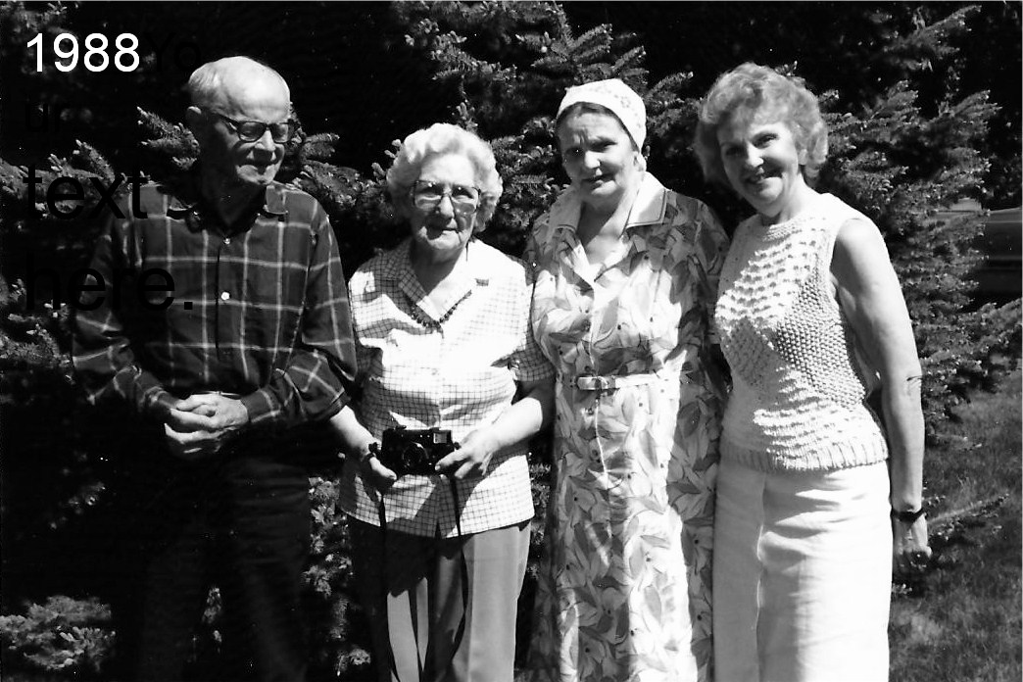

Henry and Mary (nee Enns) Kornelsen, Liesa (nee Kornelsen) Reger, Irene (nee Willms) Woodsit

In 1989 I went to Russia to re-unite with my family. I stayed for nearly two months. My granddaughter and her husband came to visit me in December 1988. Family Lesesch in Germany has looked after me very well. I have to eat and clothes to wear, but no longer my health. The difficult war years and afterwards have left their traces. But the longing for the ones in Russia has not left me. Every day I think of them and pray for them. I ask myself, what I really achieved here on earth. Three times I had to leave everything behind and lost parents, siblings, my dear husband and father of my children, house and home.

I am consoled that the Lord and Redeemer has provided a place for me and my family, and nobody will chase us away here on earth. Only, it is lonely for me. I am the only one left of five good siblings. In Canada there are still siblings by Papa's first wife. Two are still alive, two are dead. The family circle is getting smaller.

Translated from Liesa Reger’s German account into English by Ella Pankatz Brantford, Ontario 12/2010

A2Jacob H. Kornelsen | *Aug. 1, 1849 Pordenau, Molotschna Colony |  | +May 6,1926 Morden, Man.
Mrs. Maria Peters nee Nickel married Nov. 25, 1871 |  |  | +Apr.17, 1874
B1 Jacob | *Oct. 28,1872 |  | +Dec.4, 1876
 | Jacob H. Kornelsen remarried June 19, 1875 by Rev. Bernhard Harder
Helena Martens | *June 15, 1851 Tiegenhagen, Mol. | Daughter of Jacob Martens and Maria, nee Willms | +June 8, 1945 Leamington, On.
All children were born in Tiegenhagen, Mol., Russia –
Parents emigrated to Canada in 1925
B2 Heinrich | *Apr.17,1876 | +1947  In Archangelsk, USSR  By starvation | - Maria Voth  +Apr.12,1904 in Tiegenhagen
B3 Jacob | *Jan. 12, 1878 | +Jan.27, 1879
B4 Maria | *Sep.30, 1879 | +Apr.15, 1881
B5 Sara | *Feb.5, 1882 | +Oct. 12, 1979 | Gerh. Schellenberg
B6 Johann | *June 19, 1884 | +Sep. 13, 1885
B7 Maria | *July 5, 1886 | +Oct.20, 1894
B8 Helena (Lena) | *Oct.1, 1888 | +Apr. 3, 1980 | Gerhard Penner
B10 Katharina (Tina) | *Sep.5, 1893 | +Feb.2, 1984  In Saskatoon | Jacob Thiessen
B11 Maria | *Feb.2, 1897 | +Jan.4,1971 | Heinrich Willms
B2Heinrich Kornelsen  All children born in Tiegenhagen, Mol. | *Apr.17,1876
  +1947  In Archangelsk, USSR  By starvation | - Maria Voth  +Apr.12,1904 in Tiegenhagen
C1 Jacob | *Mar.14, 1899 | +Apr.10, 1948 | - Klara Moss
C2 Helena | *Apr.14, 1899 | +Sep. 8, 1899
C3 Maria | *Apr. 22, 1900 |  | Wilhelm Krause
C4 Helena | *June 17,1901 |  | Kornelius Neufeld
C5 Sara | *Jan. 4, 1903 | Dec.8, 1903
C6 Heinrich | *Mar. 1, 1904 |  | Maria Enns
B2 Heinrich Kornelsen remarried May 27, 1906 Anna Kroeker of Konteniusfeld,
Anna Kroeker | *Sep.11, 1884 | +Oct.11, 1936 Tiegenhagen
C7 Anna (Nut) | *Feb.13, 1907 |  | Hans Wiebe
C8 Alexander (Sascha, Sasch) | *Sep.1, 1908 | taken 1937
C9 Sara | *Nov.20,1910 | Was in Warthegau, taken back to Karaganda
C10 Katharina (Katja | *Mar.4, 1913 |  | Hans P. Toews
C11Elisabeth (Liesa) | *May 31,1916 |  | Dietrich Reger
C12 Johann | *Nov.4, 1918 | +Nov.10, 1918
Heinrich Kornelsen remarried Aug. 13, 1939 Helena Schellenberg +1947
All children of 2nd and 3rd stayed in the USSR
C13 Agnes | *Apr.30, 1941 |  |  | Harry Flaming

