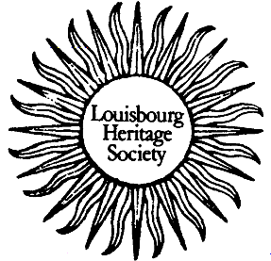
Heritage Notes
August 2005

Louisbourg’s Lighthouses – Bill O’Shea

French Lighthouse 1734 - 1758

Sailing across the Atlantic from Europe in the 1730s often led to disaster on Cape Breton’s rocky coast. Sailors sighed with relief when a spark on the horizon became the steady yellow glow marking Louisbourg’s light and safe haven.
The French claimed Cape Breton Island in 1713 and Louisbourg flourished because of the cod fishery and its location on the shipping lanes between France, the West Indies, and North America. By the 1740s more than 130 ships visited the harbour yearly.
Building a lighthouse might seem logical for a busy port, but the priority was to complete the fortifications. Instead, it was local fishermen who erected a wooden cross on the point of land at the eastern entrance to Louisbourg as a guide for ships. For a time it was called Cross Point.
The cross marked a dangerous coast. In 1725, the French ship Chameau wrecked just east of Louisbourg with the loss of over 300 lives. But it wasn’t until the fall of 1727, when the King’s ship Profond barely escaped being lost near Louisbourg, that a lighthouse was considered.
Though most officials wished to build the light at Cross Point, it was not a unanimous choice. One believed that it would be hard to land supplies, including the coal that was initially planned as the fuel for the light. He suggested placing the light in the tower of the new barracks being built across the harbour. However, the engineer wrote that the tower was not strong enough to carry the weight of the light. For several years, letters and opinions crossed the Atlantic, before it was decided to put the light at Cross Point.
The light, designed by engineer Etienne Verrier, was expected to cost 14,000 livres. The builder was civilian contractor, Francois Ganet.
By 1733 the light was almost complete and, in August, a coal and wood fire was lit on the tower to welcome a King’s ship. Five soldiers were hired to tend the fire.
But, it wasn’t until April 1, 1734 that the light became officially operational. Visible from

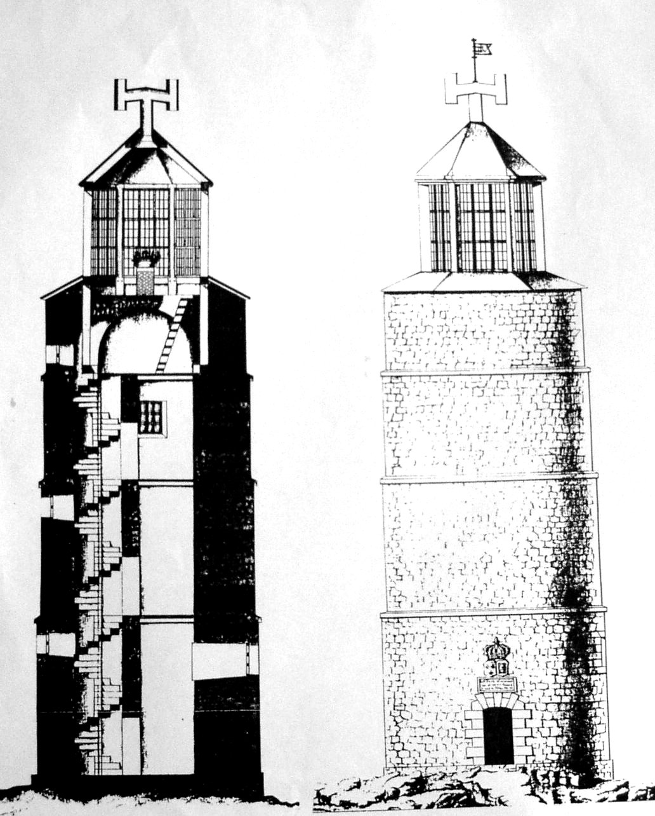

The French lighthouse, lit in 1734, before the fire of 1736 destroyed the wooden lanter on top of the tower. The light stood c. 22.3 metres high (74.6 feet).

four leagues at sea (16 kilometres), it was the first lighthouse in what was to become Canada and the second on the entire coast of North America after Boston Harbour, built in 1713.
The completed lighthouse stood 22.3 metres high (74.6 feet). The tower was mortared fieldstone topped by a six-sided wood frame lantern containing large windows. The lantern was covered by a slate roof. A lead plaque recording engineer Verrier’s and contractor Ganet’s role in constructing the lighthouse was set over the door, and a medal commemorating the founding of Louisbourg in 1720 was buried in the foundation. It was a magnificent structure and worthy of the capital of the Ile Royale colony.
The illuminant for the light was cod oil - not coal. About 90 litres of oil (22.5 gallons) was held in a bronze basin 1 metre (1.2 yards) across and 25 cm (10 inches) deep. A copper ring slightly smaller than the basin, was floated on the surface of the oil by pieces of cork. Thirty-one copper tubes with cotton wicks were soldered at intervals around the ring and extended 2.5 cm (1 inch ) above the cod oil. The basin stood on a brick pedestal in the center of the lantern.
Near the tower there was a building to house the lightkeeper and store supplies.
The light operated from April 1 to December 31, and to pay for its maintenance a duty was levied on ocean going and coastal shipping. Once the light became operational a full-time lightkeeper was hired.
The success of the light was short-lived, for around midnight on September 11/12, 1736, fire destroyed the wooden lantern. Until a new lantern was constructed a coal and wood fire was lit on an iron grill placed on the open tower. Louisbourg officials reported that the fire was not as bright as the cod oil light and the open fire could not be maintained at the worst times of the year.
Etienne Verrier drafted the plans for a new lantern and the work was completed in July 1738 at a cost of 12,100 livres. This lantern was designed to be fireproof, the first such structure in North America. Six cut stone pillars supported a brick roof covered in lead. The window frames were iron. The new lantern was about 1.2 metres (4.2 feet) wider and 2.9 metres (9.6 feet ) taller than the first lantern giving the repaired lighthouse a total height of 24.3 metres (81.5 feet).
The fuel, as before, was cod oil held in a flat-bottomed basin sitting on a stone pedestal. But the basin was wider and shallower than the original to help lessen the chance of another fire.
In 1745, Louisbourg was attacked by an army from New England and the lighthouse was a focal point for siege activity. A battery of guns erected by the New Englanders, not far from the light, fired on the French guns on Battery Island in the mouth of the harbour though the lighthouse was not damaged.
To the New Englanders, who won the seven-week siege, the light house was a wonder. British forces occupied Louisbourg for several years before it was returned to France in 1748. They spent money on the upkeep of the lantern and hired a lightkeeper.
Still, when the French returned to Louisbourg, the lighthouse needed repairs. By the early 1750s the tower was coated with a protective coat of mortar.
Peace was not to last and, in 1758, a massive and successful seven-week long military action by the British proved the death knell for the Louisbourg. The light was damaged and though it was recommended for repair it never operated again.
In the last quarter of the 18th century the lighthouse shows on harbour maps as a ruined tower that acted as a landfall for ships. But Louisbourg was no longer the economic center of Cape Breton, the British having moved the capital to Sydney, nearer the coal fields. Still, the importance of that first lighthouse cannot be underestimated. On a dangerous shore at a time when navigation was uncertain, the Louisbourg light was a welcome home.

The 1842 Lighthouse

After 1758, Cape Breton’s coast lay dark for more than two generations. But, starting in 1826, the General Mining Association consolidated the mines around Sydney harbour and shipped coal to ports on the Atlantic coast. A light was constructed at Low Point in Sydney in 1832.
That same year, a wooden beacon was built at Louisbourg on the site of the French lighthouse. It was probably a ballasted white-painted pyramid, rising 4.5 to 5.9 metres (15-20 feet) from an 2.3 metre square (8 foot) base. The beacon, indicating the mouth of the harbour, was not much better than the wooden cross that French fishermen erected on the nearby point over 100 years before since it was not visible in bad weather or at night.
The danger of the unmarked coast was underscored by the loss of the ship Astrea on Lorraine Head, near Louisbourg, in 1834. The tragic deaths of 237 Irish immigrants, and the many other wrecks on the coast, convinced various governments to build landfall lights and life saving stations on St. Paul’s and Scatarie Islands in 1839.
Coastal lights were also important and, in 1842, Thomas Jost of Sydney, with ship owners and mariners, successfully petitioned Halifax for a light at Louisbourg.
The completed, light was advertised in a Notice to Mariners in the Nova Scotian beginning on October 20, 1842. It stated that “a new light house has been erected where a beacon stood, on the site of the old French light . . . and

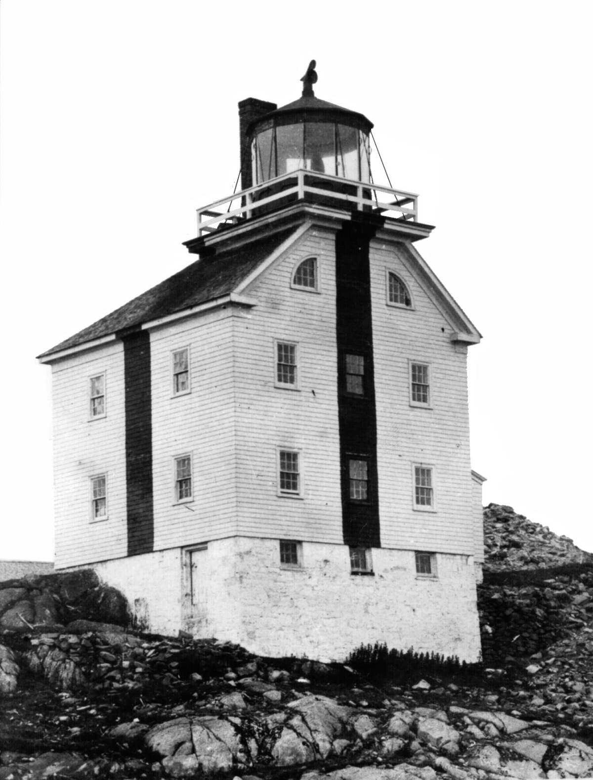

The Louisbourg Lighthouse 1842-1923, south side.
The lighthouse was wood frame, shingled and painted white with a black vertical line on three sides. It was 10.5 metres (35 feet) high to the vane on a 8.6 metre square (29 foot square), stone foundation.
Photo taken after 1889.

will exhibit a plain white light visible on the seaward side from Gabarus Point westerly to south eastern extremity of Cape Breton easterly. The lantern is 85 feet above the sea level, is placed in a square building about sixty fathoms from the shore, painted white with a perpendicular black stripe on each side, to distinguish it from other Light Houses in day time and to render it conspicuous in winter when the back land is covered with snow.”
The building was constructed by Samuel Crawford and the lantern by Amos Pedlar, for £1140.7.4, and was seen from 26.5 kilometres (c 16 miles) out to sea.
The new lighthouse was a major addition to the quiet harbour, which in 1827 recorded 141 people in 23 households. It immediately became a tourist attraction, with the captains and crews of ships in the harbour visiting it regularly.
The first description of the light apparatus was in 1857 when it consisted of 4 catoptric lamps with reflectors and 4 Argand lamps without reflectors. Beginning in 1864 kerosene replaced seal oil as fuel for the lamps since kerosene burned brighter and was less expensive.
With Confederation, in 1867, the responsibility for lighthouses passed from Nova Scotia to the federal department of Marine and Fisheries. A 1870 report noted that the Louisbourg light was important as a harbour and coast light since the harbour was the only safe one between Scatarie and Arichat.
In 1875, the Louisbourg light consisted of an "Iron lantern 10 feet in diameter, with eight sides, glazed with 17 x 11 inch glass . . . The lantern is dark towards the land side; and the illuminating apparatus consists of four circular-burner lamps with 20-inch reflectors, and five A lamps with 12-inch reflectors . . . The annual consumption of oil is about 530 gallons.” By this date the lantern was considered old and due for replacement.
The Superintendent of Lights for Nova Scotia, writing in 1906, notes, “this light is not a small one, by any means. The illuminating apparatus consists of 11 mammoth flat wick lamps fitted with 22” x 12” reflectors in a 10 foot iron lantern.”
By 1895, H. M. Whitney consolidated many of the mines, purchased or leased a fleet of coal boats, and built the Sydney & Louisburg Railway. This ensured that coal could leave Cape Breton year round through Louisbourg’s ice-free harbour. A period of prosperity arrived that would last until the 1920s.
The increased shipping traffic lead to changes in the navigational aids. Louisbourg was declared a port in 1879, and a pilot service was established. A storm signal mast was erected by the weather service in 1875, leading lights built on the north shore in West Louisbourg in 1897, a fog siren installed in February 1902, and a Marine Hospital constructed in 1905.
The first fog alarm was a Scotch siren, purchased in Scotland, with engines, tanks and compressors made in Canada. A small building holding the siren machinery was constructed at the edge of the cliff about 120 metres (133 yards) south of the lighthouse along with a brick engine house. Soon the Scotch siren was replaced by a newer diaphone apparatus developed in Toronto. It produced, “ a blast of more constant pitch for about one eighth the power expended by the Scotch siren.”
World War I brought the last major change in technology in the lighthouse. This consisted of a 4th order dioptric lens and 35 mm burner installed in 1915/1916. It was a “clock-gear” operated, revolving mechanism with an incandescent petroleum vapour light which cost $1,227.63. For the first time Louisbourg had a flashing light rather than a fixed light.
The lighthouse ended its life dramatically, on Saturday evening, June 2, 1923, catching fire and burning to the foundation. Louisbourg diarist Melvin S. Huntington wrote that the fire started at 7 p.m., but the alarm was not sounded until shortly after 8 p.m. and “by that time the fire had gained so much headway that it was useless to try to save the building.” The major concern of those who reached the lighthouse, including the fire fighting crew from the government ship SS Lady Laurier, was to keep the fog alarm buildings, located several hundred feet away, from burning.
After 81 years of service, the 1842 light was no longer a part of Louisbourg’s life.

The Louisbourg Lighthouse – 1923/24

Almost immediately after the fire destroyed the 1842 lighthouse, a temporary light was erected on the roof of the nearby fog alarm building. The temporary structure stood 13.5 metres high (45 feet) and was topped by a white occulting light (covered briefly at regular intervals) flashing every 12 seconds and showing 3 seconds of light. It was visible 16.5 kilometres (10 miles) out to sea.
With the short-term problem solved, the Marine Department in Ottawa wrote to its Halifax agent, suggesting the construction of a double house and a concrete light tower.
The Department’s district engineer, J.A. Leger, recommended “ . . . that a tower similar to the one erected on Georges Island, Halifax Harbour, be put up.” He also wrote that “About 1/3 of (the) remains of the old French light will have to be removed, (and the) chimney of (the) old (1842) dwelling pulled down.”
Responding to Leger’s advice the Superintendent of Lights wrote that since the temporary light was working well, it could be the model for a new type of Louisbourg light. Rather than build a new tower, he recommended a 500 mm. lantern mounted on a structure similar to a large buoy. He further reasoned that because the light and the fog alarm could share the same location, only a single dwelling was needed for the one engineer who could watch both facilities. His superiors did not agree and there is a note in the margin of his memo stating that “This would be replacing a 40,000 CP light by a 500 CP one and would not be recommended.”
This reaction is not surprising since Louisbourg was important to Cape Breton’s economy. With the arrival of the Sydney & Louisburg Railway in 1895, the town shipped millions of tons of coal to the rest of Canada, Newfoundland and New England. Even after 1919, when shipping from the harbour was largely limited to the winter months, Louisbourg was a significant port with its annual influx of coal boats, ships coming to refuel and fishing vessels. In 1925-26, for example, a total of 342 vessels entered the harbour.

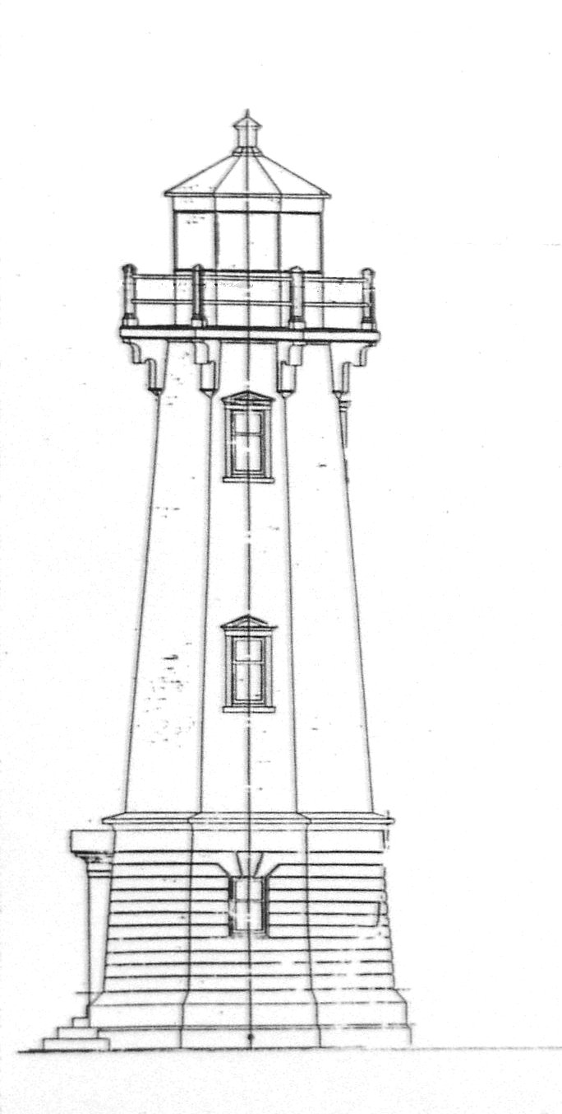

Louisbourg Light, south elevation – 1917, Department of Marine & Fisheries Plan

The plans for a new light moved forward using a 1917 design. The contract was awarded to E.M. Dickson of Atlantic Engineering Works of Sydney who, by late September 1923, was working on the foundation.
In early November there was an estimate of the cost for the lighthouse and dwelling. With the contract set at $18,100.00, inspection costs at $150.00, and the lantern from the Dominion Lighthouse at $4750.00, the total cost was projected to be $23,000.00.
The work proceeded smoothly and by December 18, 1923 the tower was complete except for the entrance door and the trim. The foundations for the house were finished and it was framed and boarded with the roof and shingling started.
By February 20, 1924, engineer Leger competed the final inspection and took over the buildings from the contractor.
The new Louisbourg light house was entered into service on February 1, 1924. The Notice to Mariners describes the light as a petroleum vapour, flashing white, catoptric light showing every 7 seconds. The fixed light was 500 candle power with flashes of 50,000 candle power. It was seen at 20 kilometres (12 miles).
The Louisbourg lighthouse measures almost 14 metres high (55 feet) from the ground to the top of the vane with the base 5.8 metres indiameter (19 feet). Its attractive octagonal form represents a classical column divided into a strongly emphasized or rusticated base, a smooth shaft, and a capital consisting of the platform with decorative brackets and a lantern. There are pedimented caps over the door and the windows. The tower is painted white and the lantern is red.
With the completion of the new light the duties of the light keeper changed. Previously, while the keeper had overall charge of the light station, there was an engineer operating the fog alarm who was paid a higher wage. This wage discrepancy caused no end of problems between the light keeper and engineer from February 1902, when D. A. Campbell became the fog alarm engineer. Campbell was replaced by William Covey in 1916. But it was not until Covey became keeper of the new light, in February 1924, that the two positions were combined in one person.

The French ruins almost lost

The construction of the new light tower drew attention to the ruins of the 18th-century French light. District Engineer Leger wrote, in mid October 1923, that in moving the debris of the French tower, he found an outline of the 18th-century foundation, 6 or 7 steps of the stairwell, the location of the door and a number of artefacts, including the lead dedication plaque which was probably located over the door after the light was built. He recommended that the foundations be preserved, changing his earlier position that they would be removed.
Awareness of historic French Louisbourg had grown over the quarter century before the new lighthouse was constructed. In 1895, on its opening day, the Sydney and Louisburg Railway brought members of the United States-based Society of Colonial Wars to Louisbourg to dedicate a monument to the military forces taking part in the siege of 1745. Five years later Prime Minister Sir Wilfrid Laurier visited the ruins of the fortress and spoke about the historic ground, “consecrated by the blood of your forefathers, the English, and my forefathers, the French. . .” Between 1901 and 1907 industrialist D.J. Kennelly stabilized ruins at the fortress site and obtained protecting provincial legislation. Then, in 1918, J.S. McLennan published his well-researched book, Louisbourg: From Its Foundation to Its Fall, 1713-1758, giving the average person access to a detailed history of 18th-century Louisbourg.
In 1921, on the recommendation of the Historic Sites and Monuments Board of Canada, the federal government bought land at the fortress to preserve the ruins and prevent artefacts from being removed. This was followed, in the summer of 1923, by a visit from members of the Board guided by J. S. McLennan and Louisbourg, Archdeacon T. F. Draper. A proposal to acquire all the historic ruins including the lighthouse was submitted.
It was only natural that when Draper saw the construction activity at the lighthouse in September 1923, he grew concerned and immediately wrote to Dr. Webster of the historic sites board suggesting that any artefacts found there should be held in safe keeping and that the ruins be preserved. Webster wrote to the director of the historic sites branch, urging that the new lighthouse be built alongside the old and that any “relics” be delivered to Draper’s care. The 18th-century lighthouse ruins were saved.
As for the artefacts, some may have been given to Archdeacon Draper for safekeeping. But there seems to have been local concern that they would leave the community and there was an effort to keep the lead dedication plaque in Louisbourg. The plaque hung in the tower until the light was automated in 1990. At that time it was transferred to the Fortress of Louisbourg where it is on display.

The Summer of 1926

The new lighthouse was the focal point for two important events in 1926: the town’s Come Home Week and the Historic Sites and Monuments Board of Canada ceremony to unveil historic plaques. The town celebrated the first day of its Come Home week on August 10, with a sports programme followed by the plaque unveilings. At 11:30 a.m. at the lighthouse Senator J. S. McLennan talked about the history of the site and Mayor Melvin Huntington welcomed the guests before unveiling the plaques. One of the plaques commemorates the French defenders of the Island Battery in 1745 and 1758, while the other commemorates the French lighthouse and the British batteries constructed in the vicinity in 1745 and 1758. They are still mounted on the light tower.

The Light in the last 50 years

In 1957 electricity came to the light and duplex house. The town of Louisbourg had electricity, beginning in 1916, and along the railroad track and coal pier there was electricity from the early 1900s. But the lighthouse was too far away to make the link economical until the Rural Electrification Act of 1957 allowed service when there were at least three customers. These three customers were the lighthouse, the head lightkeeper Wilfred Covey, and his assistant Frank Kozera.
The lighthouse lantern contained a 500 watt bulb in 1961. It is described as a catoptric apparatus with a Number 3 long-focus reflector. It appeared as white, flashing 7 seconds.
By July 1962 there was a change when the former 4th order apparatus was “ . . . replaced with a 4th order (dioptric) lens with a 1000 watt Westinghouse lamp actuated by a tim-o-matic flasher.” That year the light was also changed from a revolving light to a stationary flash, showing one flash every 7 seconds.
In 1970 the light was “semi-automated” with a 500 mm cut class lens and rotating screen with a 400 watt mercury vapour clear lamp.
By the mid 1980s there was more change as Louisbourg moved towards unmanned station status. In November 1988 the light is described as a DCB 36, revolving screen, flashing every 9 seconds and lit by a 1,000 watt lamp.
In September 1990 the Coast Guard would advertise that the Louisbourg Harbour Light was on automatic system and no longer staffed. Roy Forgeron, the last Louisbourg head lightkeeper, had retired.
The present light is an AP1-APRB-252 DC, with a 1 to 9 flash.

The Fog Alarm

The fog alarm underwent changes as well. In 1953, the diaphone foghorn was replaced by a new F diaphone horn. In 1961 a new fog alarm building was constructed. The fog alarm equipment was installed in December 1962. The building was wired, but the Power Commission did not extend electricity to the fog alarm until May 1965 when 3 phase power was run to the building. The fog alarm was still the Type F, Diaphone.
In 1971 the F Diaphone was phased out in favour of a Stone-Chance 400 electric horn. Similar equipment was being installed at St. Paul’s Island, Western Head and Cape North. A memo prepared for the Fisherman’s Broadcast, dated 5 November 1971, noted a new fog horn at Louisbourg, with a blast of 6 seconds and silence for 54.
In 1974 the fog alarm sensor was put into operation and, by 1979, and possibly several years earlier, there was another change when an AGA 1000 (2KW) watt horn was installed.
The present-day horn is a Tidland AV 560 with a 2 second blast followed by 18 seconds of silence.

Buildings

There were a number of buildings associated with the light station over the years. In 1963 these included the lighthouse, duplex house, fog alarm building, storehouse, boat house, coal house and oil storage building. Each side of the house had 5 rooms ( 3 bedrooms, kitchen and living room) and a bath. The house and the old fog alarm building were removed in late 1971 and early 1972. New homes for the keepers and their families consisted of three bungalows installed in 1967/68. These have since been sold and at present there is one small building in the vicinity of the light which provides power through solar energy.

The Fortress Reconstruction

At Lighthouse Point the ruins of the 18th- century French and 1842 lights are protected by Parks Canada. The operation of the modern light and foghorn remains under the control of the Department of Fisheries and Oceans.
The partial reconstruction of the Fortress of Louisbourg, begun in 1960, played a part in the life of the modern Louisbourg lighthouse. The ambitious initial plans for the project saw the removal of the 1923/24 tower and its replacement by a reconstruction of the 18th century French light, housing a modern light system. There was also discussion of putting fog alarm equipment underground to hide it from tourists and building new light keeper accommodations at a distance from the light. As enthusiastic as the plans were, by the late 1960s it was obvious that Parks would not build a replica of the French lighthouse. The story of the lighthouses was presented in a small building through 4 attractive models of the various lights and for years they were enjoyed, along with the view, by the many visitors to the lighthouse area. At present these models are located in an exhibit at the Fortress visitor center.

Heritage Building status

The Federal Heritage Building Review Office in Ottawa (FHBRO) designated the light house a Recognized heritage property ". . . because of its association with the theme of aid to navigation, because of its historical and environmental significance as the site of the first lighthouse in Canada and the second on the North American continent, and for architectural reasons.
The modern Louisbourg light, joins the ruins of the French and Nova Scotia lights as, an important Canadian cultural property

Louisbourg Light Keepers, 1733-1990

- Soldiers: Desloriers, Sans Chagrin, Vadeboncoeur, La Girofflee and La Jeunesse tended a wood fire on the almost completed light tower in August 1733.
- Jean Grenard dit Belair (1674-1744) a retired sergeant of the colonial troops, was light keeper from 1733 until 1744.
- Georges DesRoches, a French resident who stayed in Louisbourg during the post 1745 siege occupation, was hired as lightkeeper by the British.
- Laurence Kavanagh III (1790-1862) born at St. Peter’s, C.B., was light keeper between 1842 and 1860/62. He was a member of the legislature representing Cape Breton County (1830-1836) and Richmond County (1836-1840).
- Laurence Kavanagh IV (c1823-1898) was born in St. Peter’s but lived in Louisbourg from the 1840s. He was the light keeper between 1860/62 and 1889 when he retired to St. Peter’s.
- William Burke, of Main-a-Dieu, was appointed light keeper on 26 June 1889. He traded jobs with James P. Burke, the Fisheries Overseer in Main a Dieu.
- James P. Burke (1853-1921), born in Main-a-Dieu, was the light keeper from 27 May 1890 until November 1897.
- Phillip Price (1853-1912), born in Louisbourg, was light keeper from 1897 to 1912.
- William. A. Cameron (c1856-1934), of Big Lorraine, was light keeper from December 1912 until February 1924. He was in charge of the light when it caught fire and burned in June 1923
- William Henry Covey (1871-1924), born in St. Margaret’s Bay, N.S., was hired as fog alarm engineer in 1916. He was lightkeeper for 5 months in 1924, beginning on February 26.
- Wilfred Covey, (1898-1975) The son of William Covey was head lightkeeper from 1924 until 1964. Arthur Covey and Harold Covey were early assistants.
Frank Kozera was 1st Assistant at Louisbourg, from 1956 to1977 (when he move to Black Rock light)
Carl Goyetche was 2nd Assistant between 1960 and 1972 (when he move to South Bar light)
- M. J. Tanner was in Louisbourg from 1964 to 1966 when he moved to St. Paul’s Island.
- Roy Forgeron, presently living in Main-a-Dieu, was the last head lightkeeper at Louisbourg. He reported for work on 21 November 1966 and retired in 1990.

References

For the French lighthouse, the significant archival references are found in the archives at the Fortress of Louisbourg National Historic Site of Canada. The ACB series is correspondence from the Minister of the Navy (Marine) to the colony. The C11B series is memoranda originating in the colony and directed to the Minister. There is also a series of plans that can be consulted.

Barkham, Selma, Lighthouse Report, Fortress of Louisbourg National Historic Site of Canada, 1968, Archives.

Bush, Edward F. The Canadian Lighthouse. Canadian Historic Sites: Occasional Papers in Archaeology and History – No. 9, National Historic Parks and Sites Branch, Parks Canada, Indian and Northern Affairs, Ottawa, 1974

Donovan, Kenneth. Canada’s First Lighthouse Keeper: Jean Grenard dit Belair, 1644-1744, Fortress of Louisbourg, January 2000.

Dunn, John R., The Louisbourg Lighthouse, Manuscript Report Number 32, National Historic Sites Service, Department of Indian Affairs and Northern Development, July 1971.

Fichou, Jean-Christophe, Noël Le Hénaff, Xavier Mével, Phares, Histoire du Balisage et de L’Éclairage des Côtes de France. Editions Le Chasse-Maré/ArMen, 1999 ( ISBN 2 903708 92 4 ).

Johnston, John. Canada’s First Lighthouse. Atlantic Advocate, Vol. 76, No. 6, Feb 1986, pp. 26-27.

O’Shea, Bill . The 1842 Louisbourg Lighthouse, Heritage Notes, No. 13, March 2002

O’Shea, Bill. The Louisbourg Lighthouse ( Part 1 – constructing the light 1923/24), Heritage Notes, No 16, March 2003 in the Louisbourg Seagull for March 2003.

O’Shea, Bill. Louisbourg’s French Lighthouse 1734-1758, Heritage Notes, Lighthouse Day, May 2003.

Stevenson, D. Alan. The World’s Lighthouses Before 1820. London, Oxford University Press, New York, Toronto, 1959.

Thanks also to Michael Kehoe, John MacQuarrie, Frank Kozera and Roy Forgeron.

© Louisbourg Heritage Society, Louisbourg, N.S., August 2005

The Louisbourg Lighthouse Society

The Society includes Gerry Gartland, Jean Bagnell, Iris Stevens, Allister MacDonald and Carter Stevens.
The Society can be reached at 7 Kent Street, Louisbourg, Nova Scotia, B1C 1E5
The Louisbourg Lighthouse Society website is: http://fortress.uccb.ns.ca/LouisbourgLighthouseSociety/

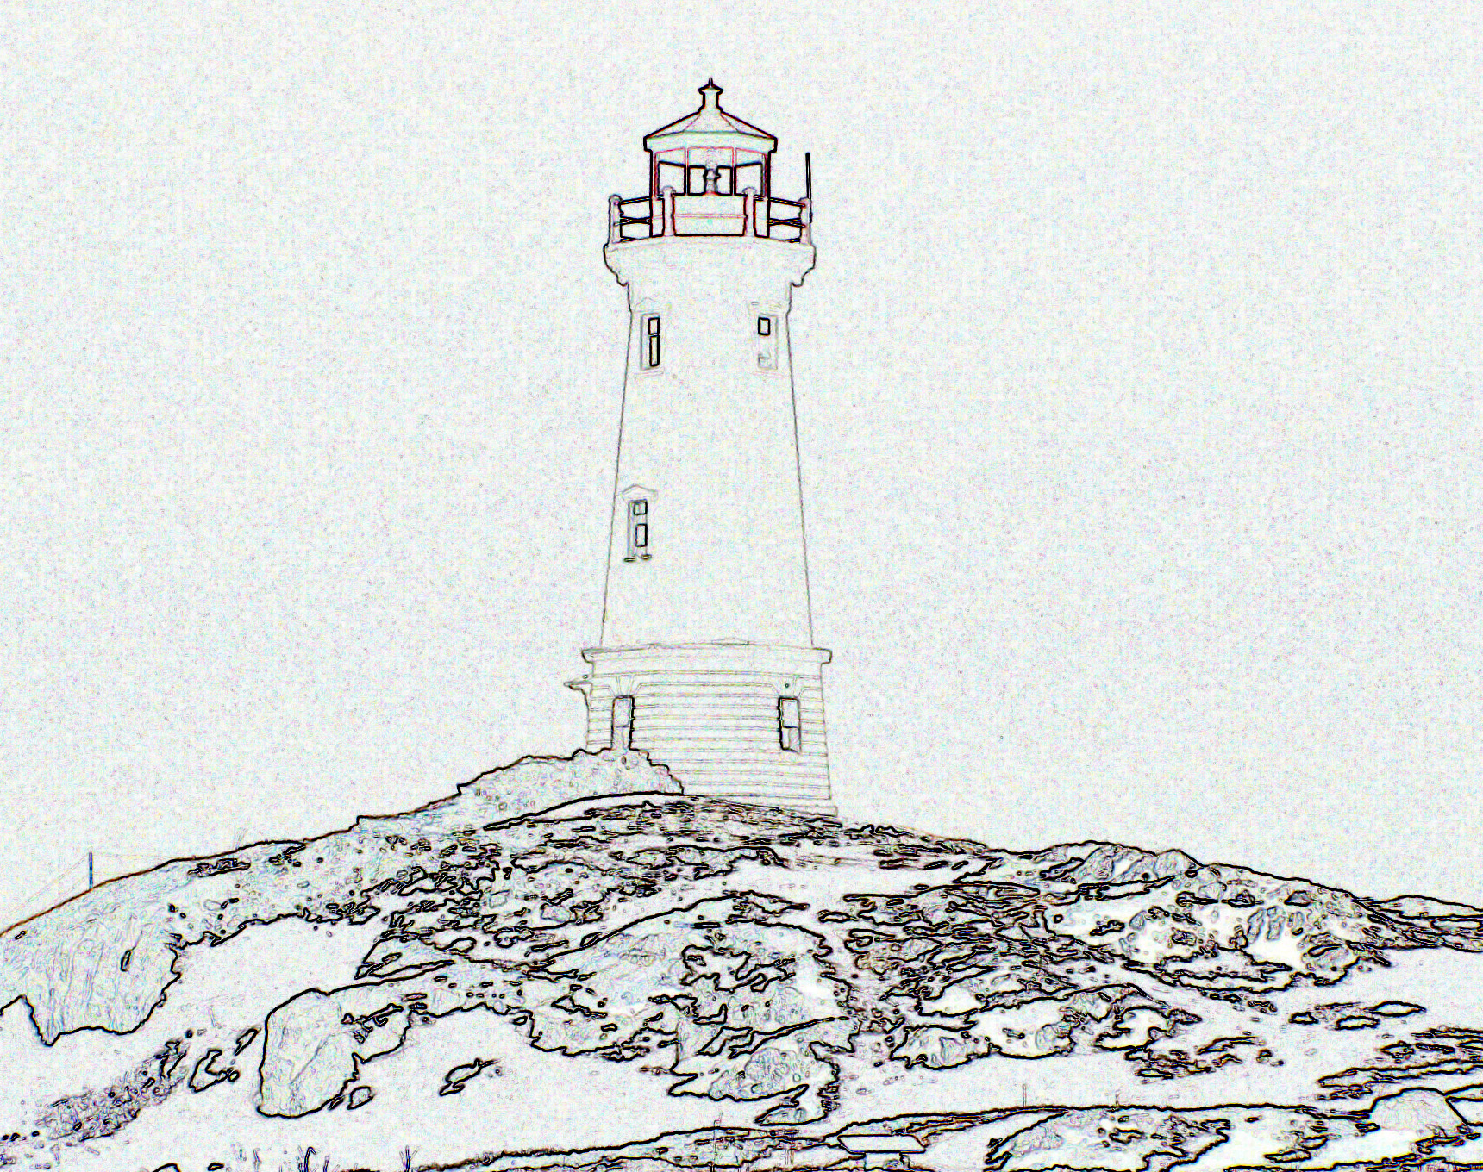

The Louisbourg Lighthouse in late winter 2005

